**Historical reconstruction of the population dynamics of southern right whales in the southwestern Atlantic Ocean**

Romero, M.A., M.A. Coscarella, J.C. Pedraza, R. González and E.A. Crespo

**Supplementary material**

Table S1. Observed catch series (number of individuals) used in this study. : annual catch values..

|  |  |  |  |  |  |
| --- | --- | --- | --- | --- | --- |
| Year |  |  | Year |  |  |
| 1678 | 20 | 30 | 1849 | 2 | 28 |
| 1679 | 20 | 30 | 1850 | 6 | 34 |
| 1680 | 20 | 30 | 1851 | 1 | 1 |
| 1681 | 20 | 30 | 1852 | 1 | 1 |
| 1682 | 20 | 30 | 1853 | 0 | 2 |
| 1683 | 20 | 30 | 1854 | 0 | 0 |
| 1684 | 20 | 30 | 1855 | 0 | 2 |
| 1685 | 20 | 30 | 1856 | 1 | 44 |
| 1686 | 20 | 30 | 1857 | 6 | 8 |
| 1687 | 20 | 30 | 1858 | 7 | 19 |
| 1688 | 20 | 30 | 1859 | 5 | 6 |
| 1689 | 20 | 30 | 1860 | 8 | 14 |
| 1690 | 20 | 30 | 1861 | 0 | 10 |
| 1691 | 20 | 30 | 1862 | 5 | 16 |
| 1692 | 20 | 30 | 1863 | 15 | 34 |
| 1693 | 20 | 30 | 1864 | 7 | 22 |
| 1694 | 20 | 30 | 1865 | 0 | 23 |
| 1695 | 20 | 30 | 1866 | 5 | 17 |
| 1696 | 20 | 30 | 1867 | 0 | 3 |
| 1697 | 20 | 30 | 1868 | 0 | 24 |
| 1698 | 20 | 30 | 1869 | 0 | 45 |
| 1699 | 20 | 30 | 1870 | 0 | 19 |
| 1700 | 20 | 30 | 1871 | 0 | 16 |
| 1701 | 20 | 30 | 1872 | 0 | 25 |
| 1702 | 20 | 30 | 1873 | 0 | 7 |
| 1703 | 20 | 30 | 1874 | 0 | 27 |
| 1704 | 20 | 30 | 1875 | 0 | 10 |
| 1705 | 20 | 30 | 1876 | 0 | 5 |
| 1706 | 20 | 30 | 1877 | 0 | 4 |
| 1707 | 20 | 30 | 1878 | 2 | 17 |
| 1708 | 20 | 30 | 1879 | 5 | 21 |
| 1709 | 20 | 30 | 1880 | 0 | 27 |
| 1710 | 20 | 30 | 1881 | 0 | 12 |
| 1711 | 20 | 30 | 1882 | 0 | 21 |
| 1712 | 20 | 30 | 1883 | 0 | 36 |
| 1713 | 20 | 30 | 1884 | 0 | 15 |
| 1714 | 20 | 30 | 1885 | 0 | 7 |
| 1715 | 20 | 30 | 1886 | 0 | 12 |
| 1716 | 20 | 30 | 1887 | 1 | 28 |
| 1717 | 20 | 30 | 1888 | 4 | 23 |
| 1718 | 20 | 30 | 1889 | 3 | 40 |
| 1719 | 20 | 30 | 1890 | 0 | 13 |
| 1720 | 20 | 30 | 1891 | 0 | 18 |
| 1721 | 20 | 30 | 1892 | 0 | 2 |
| 1722 | 20 | 30 | 1893 | 0 | 73 |
| 1723 | 20 | 30 | 1894 | 0 | 41 |
| 1724 | 20 | 30 | 1895 | 0 | 8 |
| 1725 | 20 | 30 | 1896 | 0 | 0 |
| 1726 | 20 | 30 | 1897 | 0 | 2 |
| 1727 | 20 | 30 | 1898 | 0 | 0 |
| 1728 | 20 | 30 | 1899 | 0 | 32 |
| 1729 | 20 | 30 | 1900 | 0 | 0 |
| 1730 | 20 | 30 | 1901 | 0 | 0 |
| 1731 | 20 | 30 | 1902 | 0 | 0 |
| 1732 | 20 | 30 | 1903 | 0 | 0 |
| 1733 | 20 | 30 | 1904 | 0 | 0 |
| 1734 | 20 | 30 | 1905 | 0 | 0 |
| 1735 | 20 | 30 | 1906 | 0 | 0 |
| 1736 | 20 | 30 | 1907 | 93 | 93 |
| 1737 | 20 | 30 | 1908 | 65 | 65 |
| 1738 | 20 | 30 | 1909 | 56 | 56 |
| 1739 | 20 | 30 | 1910 | 117 | 117 |
| 1740 | 20 | 30 | 1911 | 95 | 95 |
| 1741 | 20 | 30 | 1912 | 26 | 26 |
| 1742 | 20 | 30 | 1913 | 67 | 67 |
| 1743 | 20 | 30 | 1914 | 21 | 21 |
| 1744 | 20 | 30 | 1915 | 19 | 19 |
| 1745 | 20 | 30 | 1916 | 15 | 15 |
| 1746 | 20 | 30 | 1917 | 54 | 54 |
| 1747 | 20 | 30 | 1918 | 14 | 14 |
| 1748 | 104 | 196 | 1919 | 15 | 15 |
| 1749 | 104 | 196 | 1920 | 13 | 13 |
| 1750 | 104 | 196 | 1921 | 10 | 10 |
| 1751 | 20 | 30 | 1922 | 1 | 1 |
| 1752 | 20 | 30 | 1923 | 12 | 12 |
| 1753 | 20 | 30 | 1924 | 12 | 12 |
| 1754 | 20 | 30 | 1925 | 1 | 1 |
| 1755 | 20 | 30 | 1926 | 1 | 1 |
| 1756 | 20 | 30 | 1927 | 3 | 3 |
| 1757 | 20 | 30 | 1928 | 3 | 3 |
| 1758 | 20 | 30 | 1929 | 1 | 1 |
| 1759 | 20 | 30 | 1930 | 1 | 1 |
| 1760 | 20 | 30 | 1931 | 2 | 2 |
| 1761 | 20 | 1750 | 1932 | 1 | 1 |
| 1762 | 20 | 1750 | 1933 | 1 | 1 |
| 1763 | 20 | 1750 | 1934 | 9 | 9 |
| 1764 | 20 | 1750 | 1935 | 0 | 0 |
| 1765 | 20 | 1750 | 1936 | 0 | 0 |
| 1766 | 20 | 1750 | 1937 | 0 | 0 |
| 1767 | 20 | 1750 | 1938 | 0 | 0 |
| 1768 | 20 | 1750 | 1939 | 1 | 1 |
| 1769 | 20 | 1750 | 1940 | 1 | 1 |
| 1770 | 20 | 1750 | 1941 | 0 | 0 |
| 1771 | 0 | 1750 | 1942 | 0 | 0 |
| 1772 | 1002 | 1002 | 1943 | 0 | 0 |
| 1773 | 1003 | 1003 | 1944 | 0 | 0 |
| 1774 | 1006 | 1006 | 1945 | 0 | 0 |
| 1775 | 1016 | 1016 | 1946 | 1 | 1 |
| 1776 | 1326 | 1326 | 1947 | 0 | 0 |
| 1777 | 994 | 994 | 1948 | 0 | 0 |
| 1778 | 970 | 970 | 1949 | 0 | 0 |
| 1779 | 880 | 880 | 1950 | 0 | 0 |
| 1780 | 772 | 772 | 1951 | 0 | 0 |
| 1781 | 700 | 700 | 1952 | 0 | 0 |
| 1782 | 645 | 645 | 1953 | 5 | 5 |
| 1783 | 635 | 635 | 1954 | 0 | 0 |
| 1784 | 670 | 670 | 1955 | 1 | 1 |
| 1785 | 907 | 907 | 1956 | 0 | 0 |
| 1786 | 857 | 857 | 1957 | 10 | 10 |
| 1787 | 1175 | 1175 | 1958 | 0 | 0 |
| 1788 | 1175 | 1175 | 1959 | 0 | 0 |
| 1789 | 854 | 854 | 1960 | 1 | 1 |
| 1790 | 720 | 720 | 1961 | 1335 | 1335 |
| 1791 | 791 | 791 | 1962 | 509 | 509 |
| 1792 | 780 | 780 | 1963 | 37 | 37 |
| 1793 | 760 | 760 | 1964 | 0 | 0 |
| 1794 | 610 | 610 | 1965 | 0 | 0 |
| 1795 | 780 | 780 | 1966 | 47 | 47 |
| 1796 | 548 | 548 | 1967 | 0 | 0 |
| 1797 | 518 | 518 | 1968 | 0 | 0 |
| 1798 | 396 | 396 | 1969 | 0 | 0 |
| 1799 | 376 | 376 | 1970 | 0 | 0 |
| 1800 | 650 | 650 | 1971 | 0 | 0 |
| 1801 | 673 | 673 | 1972 | 0 | 0 |
| 1802 | 601 | 601 | 1973 | 1 | 1 |
| 1803 | 727 | 727 | 1974 | 0 | 0 |
| 1804 | 581 | 581 | 1975 | 0 | 0 |
| 1805 | 577 | 577 | 1976 | 0 | 0 |
| 1806 | 553 | 553 | 1977 | 0 | 0 |
| 1807 | 474 | 474 | 1978 | 0 | 0 |
| 1808 | 667 | 667 | 1979 | 0 | 0 |
| 1809 | 543 | 543 | 1980 | 0 | 0 |
| 1810 | 400 | 400 | 1981 | 0 | 0 |
| 1811 | 184 | 184 | 1982 | 0 | 0 |
| 1812 | 40 | 40 | 1983 | 0 | 0 |
| 1813 | 34 | 34 | 1984 | 0 | 0 |
| 1814 | 0 | 673 | 1985 | 0 | 0 |
| 1815 | 0 | 647 | 1986 | 0 | 0 |
| 1816 | 0 | 1027 | 1987 | 0 | 0 |
| 1817 | 71 | 918 | 1988 | 0 | 0 |
| 1818 | 113 | 1154 | 1989 | 0 | 0 |
| 1819 | 201 | 1436 | 1990 | 0 | 0 |
| 1820 | 233 | 1454 | 1991 | 0 | 0 |
| 1821 | 171 | 1216 | 1992 | 0 | 0 |
| 1822 | 133 | 774 | 1993 | 0 | 0 |
| 1823 | 148 | 864 | 1994 | 0 | 0 |
| 1824 | 136 | 835 | 1995 | 0 | 0 |
| 1825 | 244 | 762 | 1996 | 0 | 0 |
| 1826 | 163 | 754 | 1997 | 0 | 0 |
| 1827 | 173 | 805 | 1998 | 0 | 0 |
| 1828 | 122 | 788 | 1999 | 0 | 0 |
| 1829 | 172 | 663 | 2000 | 0 | 0 |
| 1830 | 187 | 854 | 2001 | 0 | 0 |
| 1831 | 195 | 274 | 2002 | 0 | 0 |
| 1832 | 203 | 233 | 2003 | 0 | 0 |
| 1833 | 229 | 309 | 2004 | 0 | 0 |
| 1834 | 199 | 243 | 2005 | 0 | 0 |
| 1835 | 78 | 443 | 2006 | 0 | 0 |
| 1836 | 107 | 232 | 2007 | 0 | 0 |
| 1837 | 13 | 378 | 2008 | 0 | 0 |
| 1838 | 21 | 258 | 2009 | 0 | 0 |
| 1839 | 1 | 60 | 2010 | 0 | 0 |
| 1840 | 2 | 146 | 2011 | 0 | 0 |
| 1841 | 2 | 83 | 2012 | 0 | 0 |
| 1842 | 0 | 29 | 2013 | 0 | 0 |
| 1843 | 2 | 21 | 2014 | 0 | 0 |
| 1844 | 1 | 1 | 2015 | 0 | 0 |
| 1845 | 4 | 79 | 2016 | 0 | 0 |
| 1846 | 3 | 6 | 2017 | 0 | 0 |
| 1847 | 0 | 67 | 2018 | 0 | 0 |
| 1848 | 5 | 45 | 2019 | 0 | 0 |

Table S2. Observed total number of whales from the aerial-survey across the monitoring area south of Península Valdés to the limit of the main concentration area, totalling a coastal strip 620 km in length.

|  |  |  |  |  |
| --- | --- | --- | --- | --- |
| Flight | Year | Month | Observed whales | Julian day |
| 1 | 1999 | 5 | 5 | 139 |
| 2 | 1999 | 7 | 117 | 183 |
| 3 | 1999 | 8 | 460 | 229 |
| 4 | 1999 | 9 | 549 | 272 |
| 5 | 1999 | 11 | 172 | 314 |
| 6 | 1999 | 12 | 10 | 349 |
| 9 | 2000 | 5 | 43 | 149 |
| 10 | 2000 | 7 | 323 | 194 |
| 11 | 2000 | 9 | 558 | 271 |
| 12 | 2000 | 11 | 296 | 319 |
| 19 | 2005 | 6 | 84 | 159 |
| 20 | 2005 | 7 | 591 | 200 |
| 21 | 2005 | 9 | 733 | 251 |
| 22 | 2005 | 10 | 217 | 298 |
| 23 | 2005 | 12 | 3 | 351 |
| 25 | 2006 | 3 | 1 | 87 |
| 26 | 2006 | 5 | 4 | 130 |
| 27 | 2006 | 7 | 657 | 212 |
| 28 | 2006 | 9 | 786 | 250 |
| 29 | 2006 | 10 | 484 | 296 |
| 32 | 2007 | 5 | 57 | 143 |
| 33 | 2007 | 6 | 393 | 177 |
| 34 | 2007 | 8 | 1006 | 234 |
| 36 | 2007 | 10 | 957 | 275 |
| 37 | 2007 | 11 | 108 | 328 |
| 39 | 2008 | 4 | 16 | 120 |
| 40 | 2008 | 7 | 606 | 183 |
| 42 | 2008 | 9 | 621 | 251 |
| 43 | 2008 | 9 | 502 | 267 |
| 44 | 2008 | 11 | 173 | 315 |
| 46 | 2009 | 5 | 5 | 126 |
| 47 | 2009 | 6 | 335 | 176 |
| 48 | 2009 | 9 | 705 | 253 |
| 49 | 2010 | 4 | 6 | 117 |
| 50 | 2010 | 10 | 662 | 274 |
| 51 | 2011 | 5 | 14 | 133 |
| 52 | 2011 | 8 | 1262 | 228 |
| 53 | 2011 | 10 | 284 | 278 |
| 54 | 2012 | 5 | 58 | 144 |
| 55 | 2012 | 8 | 802 | 215 |
| 56 | 2013 | 5 | 50 | 138 |
| 57 | 2013 | 7 | 1143 | 207 |
| 58 | 2013 | 9 | 909 | 249 |
| 59 | 2013 | 11 | 161 | 317 |
| 60 | 2014 | 4 | 1 | 113 |
| 61 | 2014 | 6 | 253 | 170 |
| 62 | 2014 | 10 | 468 | 281 |
| 63 | 2015 | 4 | 3 | 113 |
| 64 | 2015 | 6 | 112 | 159 |
| 65 | 2015 | 9 | 557 | 257 |
| 66 | 2015 | 10 | 278 | 275 |
| 67 | 2015 | 11 | 102 | 322 |
| 68 | 2016 | 8 | 725 | 222 |
| 69 | 2016 | 9 | 439 | 265 |
| 70 | 2016 | 10 | 112 | 301 |
| 71 | 2017 | 7 | 542 | 188 |
| 72 | 2017 | 9 | 838 | 247 |
| 73 | 2017 | 10 | 246 | 294 |
| 74 | 2018 | 5 | 39 | 143 |
| 75 | 2018 | 8 | 1079 | 213 |
| 76 | 2018 | 8 | 1605 | 243 |
| 77 | 2019 | 7 | 301 | 189 |
| 78 | 2019 | 8 | 1077 | 237 |
| 79 | 2019 | 10 | 362 | 275 |

Table S3. Estimated abundance (: accumulated number of right whales) and variance covariance matrix from the two stage regression model. Regression parameters were estimated as follows intercept , julian day , and Julian day^2 . Year specific regression parameters () are given below.

|  |  |  |  |  |  |  |  |  |  |  |  |  |  |  |  |  |  |  |  |
| --- | --- | --- | --- | --- | --- | --- | --- | --- | --- | --- | --- | --- | --- | --- | --- | --- | --- | --- | --- |
|  |  |  |  | | | | | | | | | | | | | | | | |
| Year |  |  | 1999 | 2000 | 2005 | 2006 | 2007 | 2008 | 2009 | 2010 | 2011 | 2012 | 2013 | 2014 | 2015 | 2016 | 2017 | 2018 | 2019 |
| 1999 | 0 | 956 | 0.0261 | 0.0015 | 0.0016 | 0.0007 | 0.0014 | 0.0013 | 0.0009 | 0.0019 | 0.0008 | 0.0008 | 0.0012 | 0.0015 | 0.0015 | 0.0004 | 0.0002 | 0.0001 | 0.0004 |
| 2000 | 0.666 (0.239) | 1,868 | 0.0015 | 0.0339 | 0.0011 | 0.0007 | 0.0013 | 0.0011 | 0.0011 | 0.0017 | 0.0006 | 0.0008 | 0.0009 | 0.0017 | 0.0014 | 0.0001 | 0.0001 | 0.0004 | 0.0000 |
| 2005 | 0.219 (0.229) | 1,193 | 0.0016 | 0.0011 | 0.0294 | 0.0007 | 0.0011 | 0.0011 | 0.0005 | 0.0015 | 0.0007 | 0.0006 | 0.0012 | 0.0013 | 0.0014 | 0.0002 | 0.0001 | 0.0003 | 0.0000 |
| 2006 | 0.428 (0.243) | 1,473 | 0.0007 | 0.0007 | 0.0007 | 0.0346 | 0.0009 | 0.0007 | 0.0010 | 0.0011 | 0.0005 | 0.0008 | 0.0007 | 0.0012 | 0.0009 | 0.0001 | 0.0002 | 0.0006 | 0.0002 |
| 2007 | 0.85 (0.225) | 2,237 | 0.0014 | 0.0013 | 0.0011 | 0.0009 | 0.0272 | 0.0010 | 0.0009 | 0.0015 | 0.0007 | 0.0011 | 0.0012 | 0.0015 | 0.0014 | 0.0002 | 0.0003 | 0.0004 | 0.0000 |
| 2008 | 0.714 (0.229) | 1,953 | 0.0013 | 0.0011 | 0.0011 | 0.0007 | 0.0010 | 0.0289 | 0.0008 | 0.0012 | 0.0006 | 0.0005 | 0.0009 | 0.0010 | 0.0012 | 0.0002 | 0.0003 | 0.0002 | 0.0001 |
| 2009 | 0.437 (0.275) | 1,499 | 0.0009 | 0.0011 | 0.0005 | 0.0010 | 0.0009 | 0.0008 | 0.0515 | 0.0013 | 0.0010 | 0.0024 | 0.0009 | 0.0018 | 0.0009 | 0.0004 | 0.0003 | 0.0013 | 0.0006 |
| 2010 | 0.528 (0.337) | 1,676 | 0.0019 | 0.0017 | 0.0015 | 0.0011 | 0.0015 | 0.0012 | 0.0013 | 0.0910 | 0.0010 | 0.0020 | 0.0016 | 0.0016 | 0.0017 | 0.0002 | 0.0003 | 0.0009 | 0.0003 |
| 2011 | 0.364 (0.269) | 1,387 | 0.0008 | 0.0006 | 0.0007 | 0.0005 | 0.0007 | 0.0006 | 0.0010 | 0.0010 | 0.0477 | 0.0010 | 0.0006 | 0.0009 | 0.0008 | 0.0001 | 0.0003 | 0.0004 | 0.0001 |
| 2012 | 0.684 (0.308) | 1,936 | 0.0008 | 0.0008 | 0.0006 | 0.0008 | 0.0011 | 0.0005 | 0.0024 | 0.0020 | 0.0010 | 0.0700 | 0.0013 | 0.0019 | 0.0009 | 0.0008 | 0.0001 | 0.0017 | 0.0003 |
| 2013 | 0.847 (0.24) | 2,238 | 0.0012 | 0.0009 | 0.0012 | 0.0007 | 0.0012 | 0.0009 | 0.0009 | 0.0016 | 0.0006 | 0.0013 | 0.0340 | 0.0012 | 0.0012 | 0.0001 | 0.0001 | 0.0003 | 0.0001 |
| 2014 | 0.495 (0.283) | 1,592 | 0.0015 | 0.0017 | 0.0013 | 0.0012 | 0.0015 | 0.0010 | 0.0018 | 0.0016 | 0.0009 | 0.0019 | 0.0012 | 0.0571 | 0.0014 | 0.0000 | 0.0003 | 0.0009 | 0.0001 |
| 2015 | 0.253 (0.235) | 1,234 | 0.0015 | 0.0014 | 0.0014 | 0.0009 | 0.0014 | 0.0012 | 0.0009 | 0.0017 | 0.0008 | 0.0009 | 0.0012 | 0.0014 | 0.0321 | 0.0004 | 0.0005 | 0.0002 | 0.0003 |
| 2016 | -0.009 (0.261) | 954 | 0.0004 | 0.0001 | 0.0002 | 0.0001 | 0.0002 | 0.0002 | 0.0004 | 0.0002 | 0.0001 | 0.0008 | 0.0001 | 0.0000 | 0.0004 | 0.0432 | 0.0001 | 0.0005 | 0.0001 |
| 2017 | 0.49 (0.261) | 1,570 | 0.0002 | 0.0001 | 0.0001 | 0.0002 | 0.0003 | 0.0003 | 0.0003 | 0.0003 | 0.0003 | 0.0001 | 0.0001 | 0.0003 | 0.0005 | 0.0001 | 0.0422 | 0.0000 | 0.0000 |
| 2018 | 0.824 (0.265) | 2,201 | 0.0001 | 0.0004 | 0.0003 | 0.0006 | 0.0004 | 0.0002 | 0.0013 | 0.0009 | 0.0004 | 0.0017 | 0.0003 | 0.0009 | 0.0002 | 0.0005 | 0.0000 | 0.0445 | 0.0004 |
| 2019 | 0.293 (0.263) | 1,291 | 0.0004 | 0.0000 | 0.0000 | 0.0002 | 0.0000 | 0.0001 | 0.0006 | 0.0003 | 0.0001 | 0.0003 | 0.0001 | 0.0001 | 0.0003 | 0.0001 | 0.0000 | 0.0004 | 0.0422 |

Table 4. Estimable parameters and prior specifications for considered in the sensitivity analyses (Scens 1-14).

|  |  |  |  |  |  |  |  |  |
| --- | --- | --- | --- | --- | --- | --- | --- | --- |
| Sensitivity | Rmax |  |  | SLR | Catch | Nrecent | Q | N-haplotypes |
| Base |  |  | *unif(0.5, 0.8)* | Include |  | 2019 U[100, 10,000] | Analytical | 24 |
| 1 |  |  | *unif(0.5, 0.8)* | Include |  | 2019 U[100, 10,000] | Analytical | 24 |
| 2 |  |  | *unif(0.5, 0.8)* | Include |  | 2019 U[100, 10,000] | Analytical | 24 |
| 3 |  |  | *unif(0.5, 0.8)* | Include |  | 2019 U[100, 10,000] | Analytical | 24 |
| 4 |  |  | *unif(0.5, 0.8)* | Include |  | 2019 U[100, 10,000] | Analytical | 24 |
| 5 |  |  | *unif(0.5, 0.8)* | Include |  | 2019 U[100, 10,000] | Analytical | 24 |
| 6 |  |  | *unif(0.5, 0.8)* | Include |  | **2004 U[100, 10,000]** | Analytical | 24 |
| 7 |  |  | *unif(0.5, 0.8)* | **Exclude** |  | 2019 U[100, 10,000] | Analytical | 24 |
| 8 |  |  | *unif(0.5, 0.8)* | Include |  | 2019 U[100, 10,000] | Analytical | 24 |
| 9 |  |  | *unif(0.5, 0.8)* | Include |  | 2019 U[100, 10,000] | Analytical | 24 |
| 10 |  |  | *unif(0.5, 0.8)* | Include |  | 2019 U[100, 10,000] | Analytical | **0** |
| 11 |  |  | *unif(0.5, 0.8)* | Include |  | 2019 U[100, 10,000] | Analytical | **25** |
| 12 |  |  | *unif(0.5, 0.8)* | Include |  | 2019 U[100, 10,000] | Analytical | **37** |
| 13 |  |  | *unif(0.5, 0.8)* | Include |  | 2019 U[100, 10,000] | **Analytical + additional obs error** | 24 |
| 14 |  |  | *unif(0.5, 0.8)* | Include |  | 2019 U[100, 10,000] | **Power function** | 24 |

Table S5. Posterior mean, standard deviations and 50% and 95% Bayesian credible intervals (CI) for the key biological parameters estimated by the individual state-space assessment models of the southern right whale *Eubalaena australis*.

**S1.1 Base Case**

|  |  |  |  |  |  |  |  |
| --- | --- | --- | --- | --- | --- | --- | --- |
|  | Mean | | Median | 2.5% | 25% | 75% | 97.5% |
|  | 0.011 | | 0.01 | 0.001 | 0.006 | 0.016 | 0.028 |
|  | 65,222 | | 62,661 | 40,628 | 53,071 | 74,703 | 103,269 |
|  | 4.276 | | 3.474 | 1.072 | 1.957 | 6.095 | 10.491 |
|  | 0.65 | | 0.65 | 0.507 | 0.575 | 0.725 | 0.792 |
|  | 0.0004 | | 0.0004 | 0.0001 | 0.0002 | 0.0005 | 0.0006 |
|  | 2,185 | | 2,167 | 517 | 1,288 | 3,049 | 3,991 |
|  | 4,593 | | 4,567 | 3,819 | 4,289 | 4,868 | 5,521 |
|  | 4,702 | | 4,664 | 3,830 | 4,351 | 5,016 | 5,801 |
|  | 5,242 | | 5,120 | 3,871 | 4,602 | 5,749 | 7,259 |
|  | 0.033 | | 0.032 | 0.011 | 0.022 | 0.042 | 0.062 |
|  | 0.075 | | 0.073 | 0.041 | 0.059 | 0.088 | 0.125 |
|  | 0.077 | | 0.074 | 0.041 | 0.06 | 0.091 | 0.131 |
|  | 0.087 | | 0.082 | 0.042 | 0.064 | 0.104 | 0.163 |
|  | 0.362 | | 0.362 | 0.319 | 0.346 | 0.377 | 0.409 |
|  | 0 | | 0 | 0 | 0 | 0 | 0 |
|  | 0 | | 0 | 0 | 0 | 0 | 0 |

**S1.2 Scen 1**

|  |  |  |  |  |  |  |
| --- | --- | --- | --- | --- | --- | --- |
|  | Mean | Median | 2.5% | 25% | 75% | 97.5% |
|  | 0.024 | 0.023 | 0.013 | 0.019 | 0.028 | 0.037 |
|  | 51,372 | 50,155 | 34,875 | 43,593 | 57,933 | 74,232 |
|  | 4.176 | 3.338 | 1.058 | 1.836 | 5.975 | 10.539 |
|  | 0.646 | 0.644 | 0.506 | 0.567 | 0.722 | 0.793 |
|  | 0.0004 | 0.0004 | 0.0001 | 0.0003 | 0.0005 | 0.0006 |
|  | 838 | 753 | 270 | 539 | 1,046 | 1,894 |
|  | 4,982 | 4,961 | 4,140 | 4,669 | 5,276 | 5,933 |
|  | 5,224 | 5,199 | 4,242 | 4,860 | 5,559 | 6,353 |
|  | 6,469 | 6,379 | 4,795 | 5,777 | 7,074 | 8,630 |
|  | 0.016 | 0.015 | 0.007 | 0.011 | 0.019 | 0.031 |
|  | 0.101 | 0.099 | 0.062 | 0.084 | 0.116 | 0.154 |
|  | 0.106 | 0.103 | 0.064 | 0.087 | 0.122 | 0.165 |
|  | 0.132 | 0.127 | 0.073 | 0.104 | 0.155 | 0.223 |
|  | 0.362 | 0.361 | 0.319 | 0.346 | 0.377 | 0.41 |
|  | 0 | 0 | 0 | 0 | 0 | 0 |
|  | 0 | 0 | 0 | 0 | 0 | 0 |

**S1.3 Scen 2**

|  |  |  |  |  |  |  |
| --- | --- | --- | --- | --- | --- | --- |
|  | Mean | Median | 2.5% | 25% | 75% | 97.5% |
|  | 0.032 | 0.032 | 0.022 | 0.028 | 0.036 | 0.045 |
|  | 45,518 | 44,255 | 31,869 | 39,076 | 51,150 | 65,183 |
|  | 3.939 | 3.028 | 1.041 | 1.655 | 5.607 | 10.398 |
|  | 0.636 | 0.631 | 0.504 | 0.554 | 0.714 | 0.791 |
|  | 0.0004 | 0.0005 | 0.0001 | 0.0003 | 0.0006 | 0.0006 |
|  | 474 | 445 | 182 | 334 | 580 | 934 |
|  | 5,253 | 5,227 | 4,397 | 4,927 | 5,559 | 6,245 |
|  | 5,597 | 5,565 | 4,596 | 5,213 | 5,952 | 6,774 |
|  | 7,453 | 7,370 | 5,599 | 6,699 | 8,106 | 9,834 |
|  | 0.01 | 0.01 | 0.005 | 0.008 | 0.012 | 0.018 |
|  | 0.12 | 0.118 | 0.075 | 0.101 | 0.136 | 0.178 |
|  | 0.128 | 0.125 | 0.078 | 0.107 | 0.146 | 0.193 |
|  | 0.171 | 0.165 | 0.097 | 0.137 | 0.199 | 0.277 |
|  | 0.362 | 0.361 | 0.318 | 0.346 | 0.377 | 0.408 |
|  | 0 | 0 | 0 | 0 | 0 | 0 |
|  | 0 | 0 | 0 | 0 | 0 | 0 |

**S1.4 Scen 3**

|  |  |  |  |  |  |  |
| --- | --- | --- | --- | --- | --- | --- |
|  | Mean | Median | 2.5% | 25% | 75% | 97.5% |
|  | 0.027 | 0.026 | 0.02 | 0.023 | 0.029 | 0.038 |
|  | 48,961 | 47,787 | 34,149 | 42,003 | 54,824 | 69,502 |
|  | 4.097 | 3.26 | 1.056 | 1.78 | 5.832 | 10.467 |
|  | 0.643 | 0.641 | 0.505 | 0.563 | 0.719 | 0.792 |
|  | 0.0004 | 0.0004 | 0.0001 | 0.0003 | 0.0006 | 0.0006 |
|  | 645 | 628 | 254 | 474 | 796 | 1,125 |
|  | 5,080 | 5,063 | 4,252 | 4,772 | 5,368 | 6,001 |
|  | 5,353 | 5,329 | 4,418 | 4,995 | 5,674 | 6,427 |
|  | 6,781 | 6,679 | 5,220 | 6,138 | 7,322 | 8,877 |
|  | 0.013 | 0.013 | 0.006 | 0.01 | 0.015 | 0.021 |
|  | 0.108 | 0.105 | 0.069 | 0.091 | 0.122 | 0.159 |
|  | 0.114 | 0.111 | 0.071 | 0.095 | 0.129 | 0.17 |
|  | 0.144 | 0.139 | 0.086 | 0.117 | 0.165 | 0.233 |
|  | 0.362 | 0.361 | 0.319 | 0.346 | 0.377 | 0.408 |
|  | 0 | 0 | 0 | 0 | 0 | 0 |
|  | 0 | 0 | 0 | 0 | 0 | 0 |

**S1.5 Scen 4**

|  |  |  |  |  |  |  |
| --- | --- | --- | --- | --- | --- | --- |
|  | Mean | Median | 2.5% | 25% | 75% | 97.5% |
|  | 0.018 | 0.016 | 0.001 | 0.008 | 0.026 | 0.048 |
|  | 68,352 | 58,217 | 31,205 | 45,791 | 77,736 | 165,051 |
|  | 4.361 | 3.538 | 1.059 | 1.928 | 6.442 | 10.46 |
|  | 0.651 | 0.652 | 0.506 | 0.573 | 0.732 | 0.792 |
|  | 0.0041 | 0.0043 | 0.0006 | 0.0028 | 0.0055 | 0.0064 |
|  | 1,279 | 1,056 | 163 | 510 | 1,868 | 3,320 |
|  | 4,251 | 4,215 | 3,134 | 3,809 | 4,647 | 5,576 |
|  | 4,449 | 4,389 | 3,061 | 3,925 | 4,911 | 6,168 |
|  | 5,391 | 5,139 | 2,938 | 4,247 | 6,191 | 9,700 |
|  | 0.02 | 0.016 | 0.004 | 0.01 | 0.026 | 0.056 |
|  | 0.076 | 0.072 | 0.024 | 0.053 | 0.094 | 0.148 |
|  | 0.08 | 0.075 | 0.024 | 0.054 | 0.101 | 0.164 |
|  | 0.099 | 0.087 | 0.024 | 0.058 | 0.123 | 0.257 |
|  | 0.381 | 0.379 | 0.318 | 0.357 | 0.404 | 0.452 |
|  | 0 | 0 | 0 | 0 | 0 | 0 |
|  | 0 | 0 | 0 | 0 | 0 | 0 |

**S1.6 Scen 5**

|  |  |  |  |  |  |  |
| --- | --- | --- | --- | --- | --- | --- |
|  | Mean | Median | 2.5% | 25% | 75% | 97.5% |
|  | 0.011 | 0.01 | 0.001 | 0.005 | 0.015 | 0.025 |
|  | 65,401 | 63,721 | 42,267 | 54,251 | 74,884 | 98,081 |
|  | 4.285 | 3.481 | 1.074 | 1.957 | 6.148 | 10.487 |
|  | 0.65 | 0.65 | 0.507 | 0.575 | 0.726 | 0.792 |
|  | 0.0001 | 0.0001 | 0.0001 | 0.0001 | 0.0001 | 0.0001 |
|  | 2,380 | 2,407 | 599 | 1,450 | 3,288 | 4,135 |
|  | 4,654 | 4,625 | 3,958 | 4,374 | 4,906 | 5,502 |
|  | 4,756 | 4,717 | 3,978 | 4,433 | 5,038 | 5,746 |
|  | 5,257 | 5,146 | 4,058 | 4,680 | 5,711 | 7,097 |
|  | 0.036 | 0.036 | 0.013 | 0.025 | 0.045 | 0.062 |
|  | 0.075 | 0.073 | 0.044 | 0.06 | 0.088 | 0.122 |
|  | 0.077 | 0.074 | 0.044 | 0.061 | 0.09 | 0.127 |
|  | 0.086 | 0.081 | 0.044 | 0.065 | 0.102 | 0.157 |
|  | 0.359 | 0.359 | 0.32 | 0.345 | 0.373 | 0.402 |
|  | 0 | 0 | 0 | 0 | 0 | 0 |
|  | 0 | 0 | 0 | 0 | 0 | 0 |

**S1.7 Scen 6**

|  |  |  |  |  |  |  |
| --- | --- | --- | --- | --- | --- | --- |
|  | Mean | Median | 2.5% | 25% | 75% | 97.5% |
|  | 0.011 | 0.01 | 0.001 | 0.005 | 0.015 | 0.027 |
|  | 66,158 | 63,547 | 40,680 | 53,688 | 75,704 | 107,014 |
|  | 4.247 | 3.443 | 1.073 | 1.925 | 6.043 | 10.526 |
|  | 0.649 | 0.648 | 0.507 | 0.573 | 0.724 | 0.793 |
|  | 0.0004 | 0.0004 | 0.0001 | 0.0002 | 0.0005 | 0.0006 |
|  | 2,251 | 2,257 | 533 | 1,347 | 3,120 | 4,039 |
|  | 3,997 | 3,985 | 3,399 | 3,781 | 4,204 | 4,642 |
|  | 4,677 | 4,644 | 3,807 | 4,333 | 4,988 | 5,764 |
|  | 5,194 | 5,083 | 3,819 | 4,576 | 5,698 | 7,209 |
|  | 0.034 | 0.033 | 0.011 | 0.023 | 0.043 | 0.063 |
|  | 0.064 | 0.063 | 0.038 | 0.053 | 0.074 | 0.097 |
|  | 0.076 | 0.073 | 0.04 | 0.059 | 0.089 | 0.129 |
|  | 0.085 | 0.08 | 0.04 | 0.062 | 0.102 | 0.161 |
|  | 0.362 | 0.361 | 0.32 | 0.346 | 0.377 | 0.409 |
|  | 0 | 0 | 0 | 0 | 0 | 0 |
|  | 0 | 0 | 0 | 0 | 0 | 0 |

**S1.8 Scen 7**

|  |  |  |  |  |  |  |
| --- | --- | --- | --- | --- | --- | --- |
|  | Mean | Median | 2.5% | 25% | 75% | 97.5% |
|  | 0.012 | 0.011 | 0.001 | 0.006 | 0.016 | 0.028 |
|  | 44,325 | 42,598 | 26,104 | 35,130 | 51,283 | 73,576 |
|  | 4.22 | 3.418 | 1.07 | 1.923 | 6.009 | 10.487 |
|  | 0.648 | 0.647 | 0.507 | 0.572 | 0.723 | 0.792 |
|  | 0.0004 | 0.0004 | 0.0001 | 0.0002 | 0.0005 | 0.0006 |
|  | 2,092 | 2,004 | 447 | 1,165 | 2,992 | 3,991 |
|  | 4,595 | 4,564 | 3,823 | 4,291 | 4,868 | 5,523 |
|  | 4,705 | 4,665 | 3,823 | 4,356 | 5,010 | 5,810 |
|  | 5,249 | 5,138 | 3,858 | 4,614 | 5,755 | 7,296 |
|  | 0.046 | 0.044 | 0.015 | 0.03 | 0.06 | 0.092 |
|  | 0.112 | 0.108 | 0.057 | 0.086 | 0.133 | 0.193 |
|  | 0.115 | 0.11 | 0.058 | 0.088 | 0.137 | 0.202 |
|  | 0.13 | 0.121 | 0.059 | 0.093 | 0.157 | 0.251 |
|  | 0.362 | 0.362 | 0.32 | 0.347 | 0.377 | 0.41 |
|  | 0 | 0 | 0 | 0 | 0 | 0 |
|  | 0 | 0 | 0 | 0 | 0 | 0 |

**S1.9 Scen 8**

|  |  |  |  |  |  |  |
| --- | --- | --- | --- | --- | --- | --- |
|  | Mean | Median | 2.5% | 25% | 75% | 97.5% |
|  | 0.012 | 0.011 | 0.001 | 0.006 | 0.016 | 0.028 |
|  | 48,695 | 47,251 | 35,532 | 42,559 | 53,021 | 70,792 |
|  | 4.231 | 3.4 | 1.067 | 1.917 | 6.047 | 10.555 |
|  | 0.648 | 0.647 | 0.506 | 0.572 | 0.724 | 0.793 |
|  | 0.0004 | 0.0004 | 0.0001 | 0.0002 | 0.0005 | 0.0006 |
|  | 1,908 | 1,729 | 285 | 905 | 2,905 | 3,998 |
|  | 4,595 | 4,575 | 3,821 | 4,297 | 4,869 | 5,504 |
|  | 4,706 | 4,672 | 3,832 | 4,356 | 5,021 | 5,766 |
|  | 5,250 | 5,139 | 3,867 | 4,616 | 5,762 | 7,262 |
|  | 0.038 | 0.036 | 0.007 | 0.021 | 0.053 | 0.076 |
|  | 0.098 | 0.096 | 0.06 | 0.083 | 0.111 | 0.145 |
|  | 0.1 | 0.098 | 0.06 | 0.084 | 0.115 | 0.153 |
|  | 0.113 | 0.108 | 0.06 | 0.089 | 0.132 | 0.194 |
|  | 0.362 | 0.362 | 0.32 | 0.347 | 0.377 | 0.409 |
|  | 0 | 0 | 0 | 0 | 0 | 0 |
|  | 0 | 0 | 0 | 0 | 0 | 0 |

**S1.10 Scen 9**

|  |  |  |  |  |  |  |
| --- | --- | --- | --- | --- | --- | --- |
|  | Mean | Median | 2.5% | 25% | 75% | 97.5% |
|  | 0.011 | 0.011 | 0.001 | 0.006 | 0.016 | 0.027 |
|  | 82,367 | 80,169 | 54,382 | 70,069 | 91,694 | 124,377 |
|  | 4.249 | 3.461 | 1.074 | 1.939 | 6.064 | 10.467 |
|  | 0.649 | 0.649 | 0.507 | 0.574 | 0.724 | 0.792 |
|  | 0.0004 | 0.0004 | 0.0001 | 0.0002 | 0.0005 | 0.0006 |
|  | 2,346 | 2,346 | 750 | 1,555 | 3,101 | 4,005 |
|  | 4,595 | 4,566 | 3,816 | 4,294 | 4,866 | 5,518 |
|  | 4,706 | 4,665 | 3,835 | 4,352 | 5,020 | 5,803 |
|  | 5,251 | 5,132 | 3,853 | 4,613 | 5,759 | 7,287 |
|  | 0.028 | 0.028 | 0.012 | 0.021 | 0.034 | 0.045 |
|  | 0.059 | 0.057 | 0.034 | 0.048 | 0.068 | 0.094 |
|  | 0.06 | 0.058 | 0.034 | 0.048 | 0.07 | 0.099 |
|  | 0.068 | 0.064 | 0.034 | 0.051 | 0.081 | 0.125 |
|  | 0.362 | 0.361 | 0.319 | 0.347 | 0.377 | 0.409 |
|  | 0 | 0 | 0 | 0 | 0 | 0 |
|  | 0 | 0 | 0 | 0 | 0 | 0 |

**S1.11 Scen 10**

|  |  |  |  |  |  |  |
| --- | --- | --- | --- | --- | --- | --- |
|  | Mean | Median | 2.5% | 25% | 75% | 97.5% |
|  | 0.011 | 0.01 | 0.001 | 0.006 | 0.016 | 0.028 |
|  | 65,449 | 63,149 | 40,708 | 53,472 | 74,640 | 103,802 |
|  | 4.251 | 3.45 | 1.071 | 1.923 | 6.091 | 10.524 |
|  | 0.649 | 0.649 | 0.507 | 0.573 | 0.725 | 0.793 |
|  | 0.0004 | 0.0004 | 0.0001 | 0.0002 | 0.0005 | 0.0006 |
|  | 2,198 | 2,185 | 524 | 1,294 | 3,070 | 4,029 |
|  | 4,589 | 4,563 | 3,813 | 4,286 | 4,863 | 5,510 |
|  | 4,698 | 4,662 | 3,818 | 4,344 | 5,014 | 5,774 |
|  | 5,235 | 5,119 | 3,836 | 4,609 | 5,737 | 7,260 |
|  | 0.033 | 0.032 | 0.011 | 0.022 | 0.042 | 0.062 |
|  | 0.075 | 0.072 | 0.041 | 0.059 | 0.088 | 0.125 |
|  | 0.077 | 0.074 | 0.041 | 0.06 | 0.09 | 0.131 |
|  | 0.087 | 0.081 | 0.042 | 0.064 | 0.103 | 0.163 |
|  | 0.363 | 0.362 | 0.32 | 0.346 | 0.378 | 0.41 |
|  | 0 | 0 | 0 | 0 | 0 | 0 |
|  | 0 | 0 | 0 | 0 | 0 | 0 |

**S1.12 Scen 11**

|  |  |  |  |  |  |  |
| --- | --- | --- | --- | --- | --- | --- |
|  | Mean | Median | 2.5% | 25% | 75% | 97.5% |
|  | 0.011 | 0.01 | 0.001 | 0.006 | 0.016 | 0.028 |
|  | 65,380 | 63,131 | 40,420 | 53,235 | 74,846 | 103,595 |
|  | 4.257 | 3.464 | 1.068 | 1.956 | 6.072 | 10.473 |
|  | 0.649 | 0.649 | 0.506 | 0.575 | 0.725 | 0.792 |
|  | 0.0004 | 0.0004 | 0.0001 | 0.0002 | 0.0005 | 0.0006 |
|  | 2,186 | 2,151 | 509 | 1,300 | 3,040 | 3,996 |
|  | 4,594 | 4,571 | 3,824 | 4,297 | 4,867 | 5,488 |
|  | 4,704 | 4,669 | 3,829 | 4,356 | 5,018 | 5,760 |
|  | 5,241 | 5,125 | 3,850 | 4,619 | 5,760 | 7,214 |
|  | 0.033 | 0.032 | 0.011 | 0.022 | 0.042 | 0.062 |
|  | 0.075 | 0.072 | 0.041 | 0.059 | 0.088 | 0.125 |
|  | 0.077 | 0.074 | 0.041 | 0.06 | 0.091 | 0.131 |
|  | 0.087 | 0.081 | 0.042 | 0.064 | 0.104 | 0.163 |
|  | 0.362 | 0.362 | 0.32 | 0.347 | 0.377 | 0.409 |
|  | 0 | 0 | 0 | 0 | 0 | 0 |
|  | 0 | 0 | 0 | 0 | 0 | 0 |

**S1.13 Scen 12**

|  |  |  |  |  |  |  |
| --- | --- | --- | --- | --- | --- | --- |
|  | Mean | Median | 2.5% | 25% | 75% | 97.5% |
|  | 0.011 | 0.01 | 0.001 | 0.006 | 0.016 | 0.028 |
|  | 65,380 | 63,131 | 40,420 | 53,235 | 74,846 | 103,595 |
|  | 4.257 | 3.464 | 1.068 | 1.956 | 6.072 | 10.473 |
|  | 0.649 | 0.649 | 0.506 | 0.575 | 0.725 | 0.792 |
|  | 0.0004 | 0.0004 | 0.0001 | 0.0002 | 0.0005 | 0.0006 |
|  | 2,186 | 2,151 | 509 | 1,300 | 3,040 | 3,996 |
|  | 4,594 | 4,571 | 3,824 | 4,297 | 4,867 | 5,488 |
|  | 4,704 | 4,669 | 3,829 | 4,356 | 5,018 | 5,760 |
|  | 5,241 | 5,125 | 3,850 | 4,619 | 5,760 | 7,214 |
|  | 0.033 | 0.032 | 0.011 | 0.022 | 0.042 | 0.062 |
|  | 0.075 | 0.072 | 0.041 | 0.059 | 0.088 | 0.125 |
|  | 0.077 | 0.074 | 0.041 | 0.06 | 0.091 | 0.131 |
|  | 0.087 | 0.081 | 0.042 | 0.064 | 0.104 | 0.163 |
|  | 0.362 | 0.362 | 0.32 | 0.347 | 0.377 | 0.409 |
|  | 0 | 0 | 0 | 0 | 0 | 0 |
|  | 0 | 0 | 0 | 0 | 0 | 0 |

**S1.14 Scen 13**

|  |  |  |  |  |  |  |
| --- | --- | --- | --- | --- | --- | --- |
|  | Mean | Median | 2.5% | 25% | 75% | 97.5% |
|  | 0.011 | 0.01 | 0.001 | 0.006 | 0.016 | 0.027 |
|  | 65,219 | 62,711 | 40,336 | 53,069 | 74,676 | 104,121 |
|  | 4.281 | 3.462 | 1.075 | 1.944 | 6.119 | 10.492 |
|  | 0.65 | 0.649 | 0.507 | 0.574 | 0.726 | 0.792 |
|  | 0.0004 | 0.0004 | 0.0001 | 0.0002 | 0.0005 | 0.0006 |
|  | 2,193 | 2,166 | 505 | 1,290 | 3,071 | 4,015 |
|  | 4,591 | 4,565 | 3,822 | 4,289 | 4,866 | 5,499 |
|  | 4,700 | 4,662 | 3,836 | 4,353 | 5,008 | 5,776 |
|  | 5,237 | 5,115 | 3,864 | 4,601 | 5,740 | 7,274 |
|  | 0.033 | 0.032 | 0.011 | 0.022 | 0.042 | 0.063 |
|  | 0.075 | 0.073 | 0.041 | 0.059 | 0.089 | 0.125 |
|  | 0.077 | 0.074 | 0.041 | 0.06 | 0.091 | 0.133 |
|  | 0.087 | 0.082 | 0.041 | 0.064 | 0.104 | 0.165 |
|  | 0.363 | 0.362 | 0.32 | 0.347 | 0.377 | 0.409 |
|  | 0 | 0 | 0 | 0 | 0 | 0 |
|  | 0.462 | 0.448 | 0.274 | 0.378 | 0.529 | 0.734 |

**S1.15 Scen 14**

|  |  |  |  |  |  |  |
| --- | --- | --- | --- | --- | --- | --- |
|  | Mean | Median | 2.5% | 25% | 75% | 97.5% |
|  | 0.012 | 0.011 | 0.001 | 0.006 | 0.017 | 0.029 |
|  | 64,939 | 62,367 | 40,132 | 52,668 | 74,172 | 105,255 |
|  | 4.27 | 3.468 | 1.082 | 1.948 | 6.072 | 10.53 |
|  | 0.65 | 0.649 | 0.508 | 0.574 | 0.725 | 0.793 |
|  | 0.0004 | 0.0004 | 0.0001 | 0.0002 | 0.0005 | 0.0006 |
|  | 2,143 | 2,093 | 483 | 1,230 | 3,020 | 3,996 |
|  | 4,606 | 4,574 | 3,817 | 4,295 | 4,889 | 5,561 |
|  | 4,718 | 4,675 | 3,829 | 4,356 | 5,041 | 5,839 |
|  | 5,276 | 5,143 | 3,856 | 4,620 | 5,797 | 7,402 |
|  | 0.032 | 0.031 | 0.011 | 0.022 | 0.041 | 0.062 |
|  | 0.076 | 0.073 | 0.04 | 0.06 | 0.089 | 0.127 |
|  | 0.078 | 0.075 | 0.04 | 0.061 | 0.092 | 0.134 |
|  | 0.088 | 0.082 | 0.041 | 0.065 | 0.106 | 0.169 |
|  | 0.502 | 0.493 | 0.336 | 0.432 | 0.563 | 0.718 |
|  | -0.034 | -0.034 | -0.083 | -0.051 | -0.017 | 0.015 |
|  | 0 | 0 | 0 | 0 | 0 | 0 |

Figure S1. Posterior probability (thick line) and post-model pre-data (thin line) distributions of the key biological parameters for the base case and sensitivity scenarios of the assessment of southern right whale (SRW) *Eubalaena australis*. The posterior probability distribution of the base case is illustrated in the thick grey line.

S1.1 Base Case

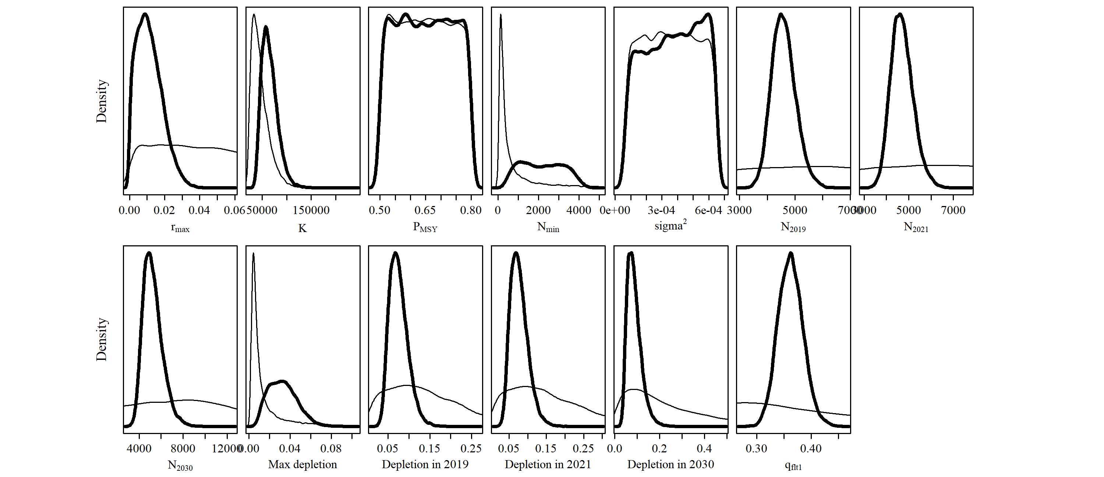

S1.2 Scen 1

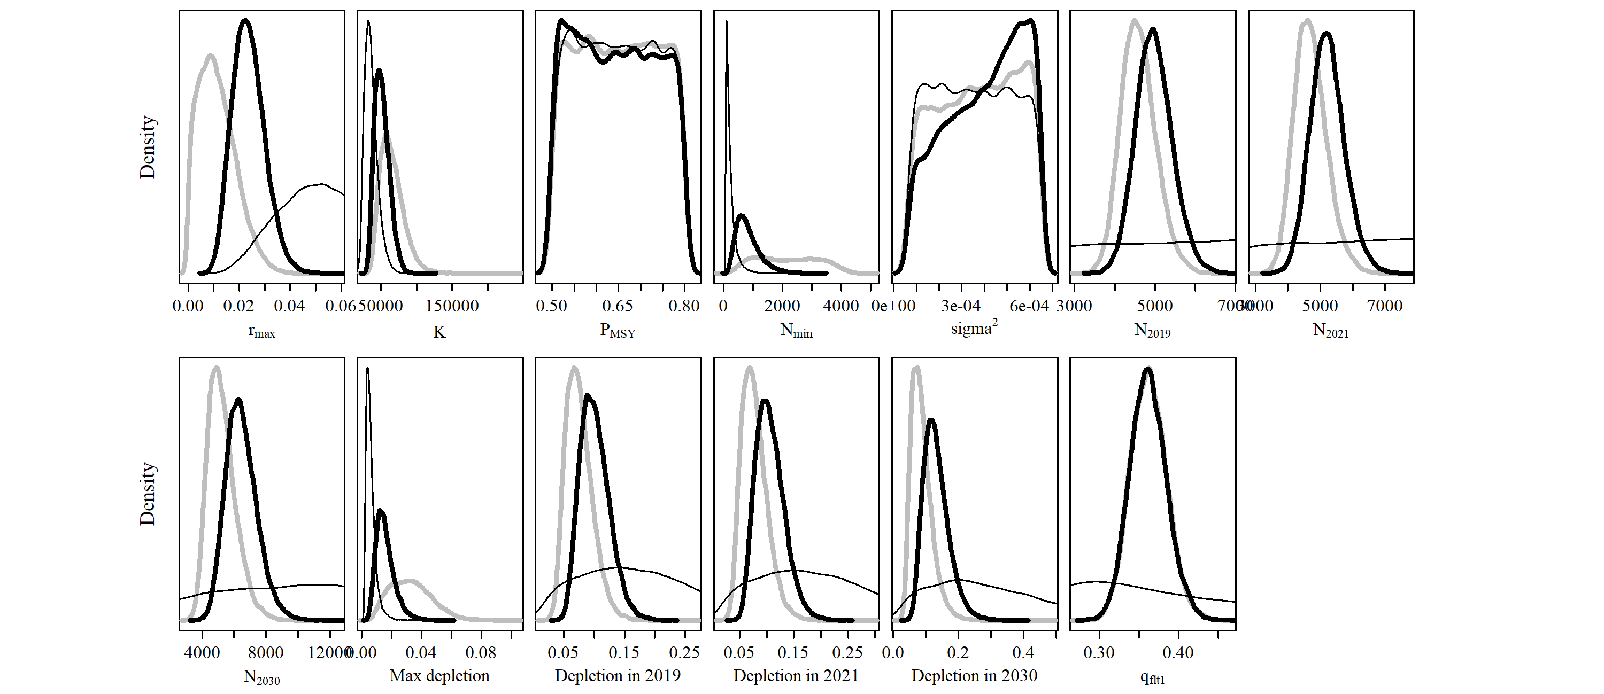

S1.3 Scen 2

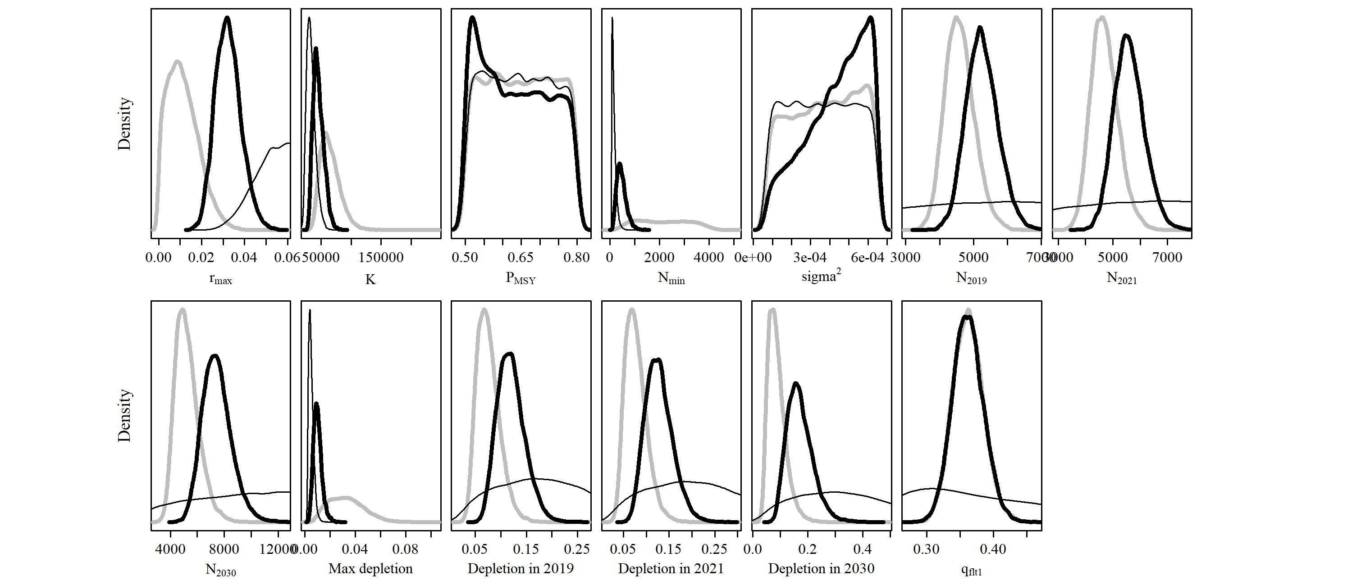

S1.4 Scen 3

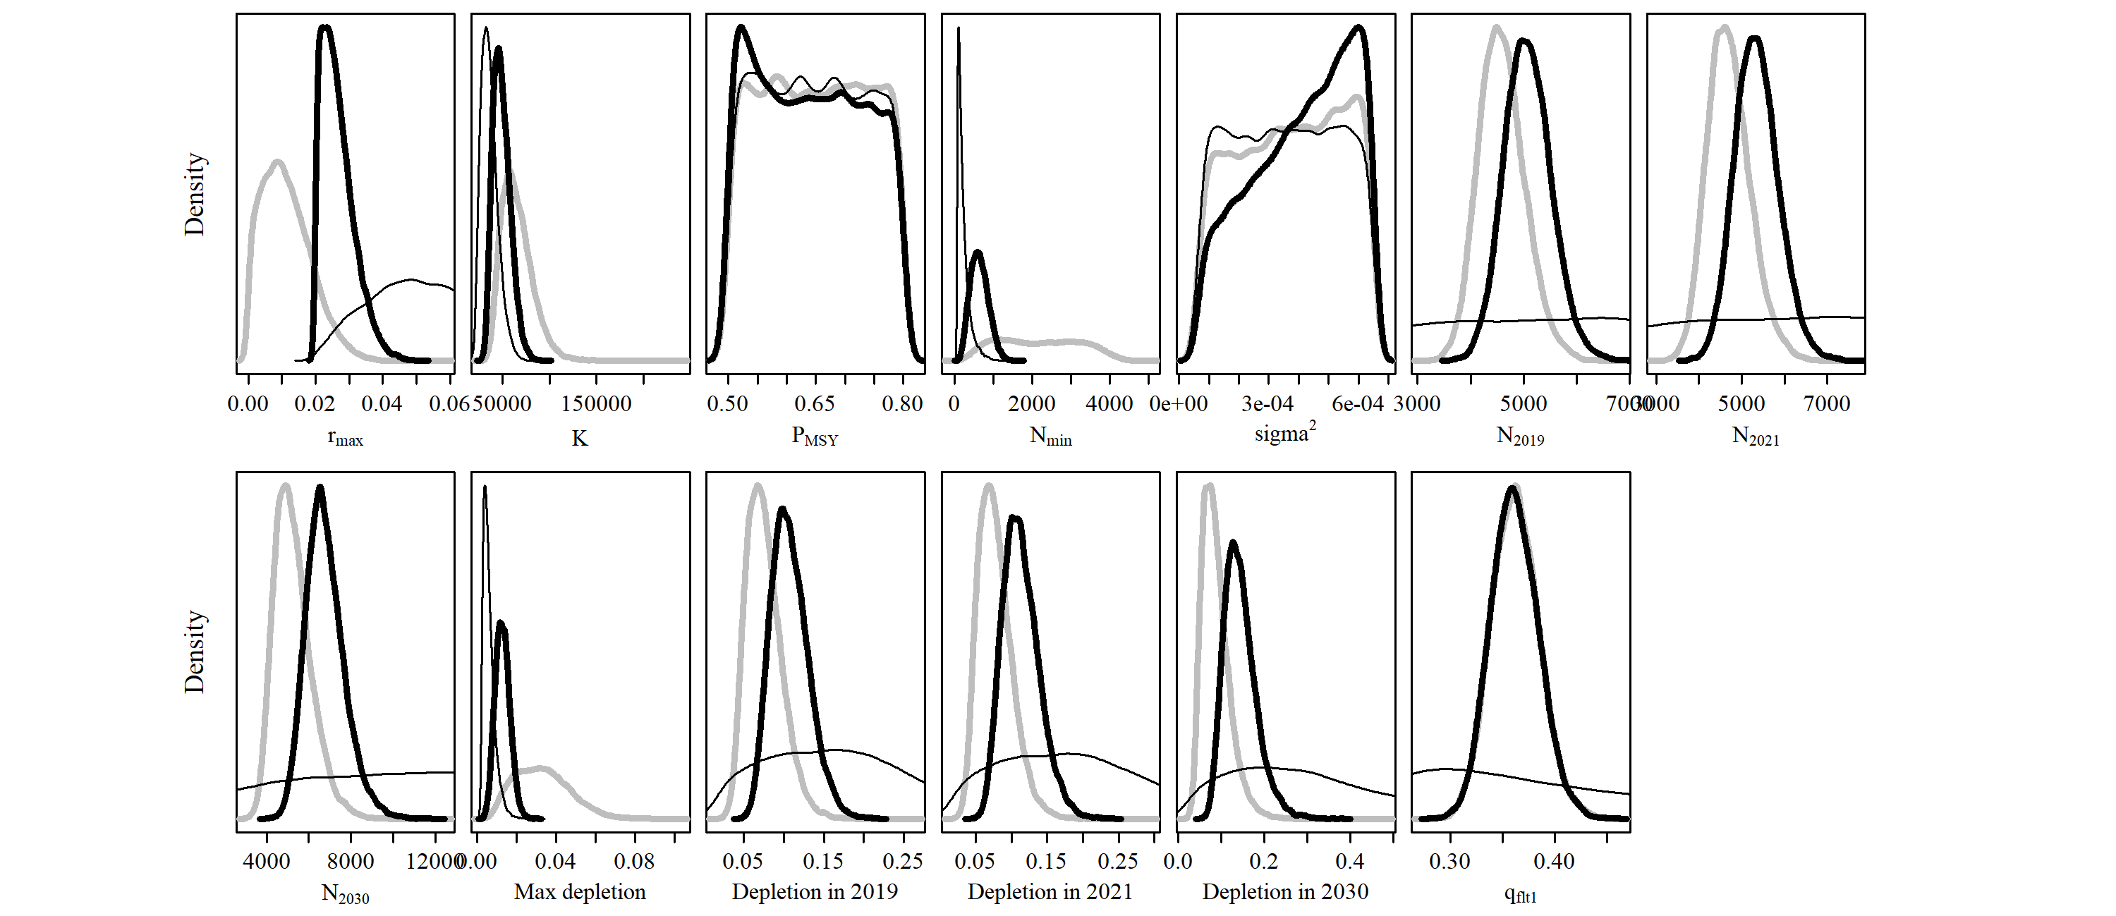

S1.5 Scen 4

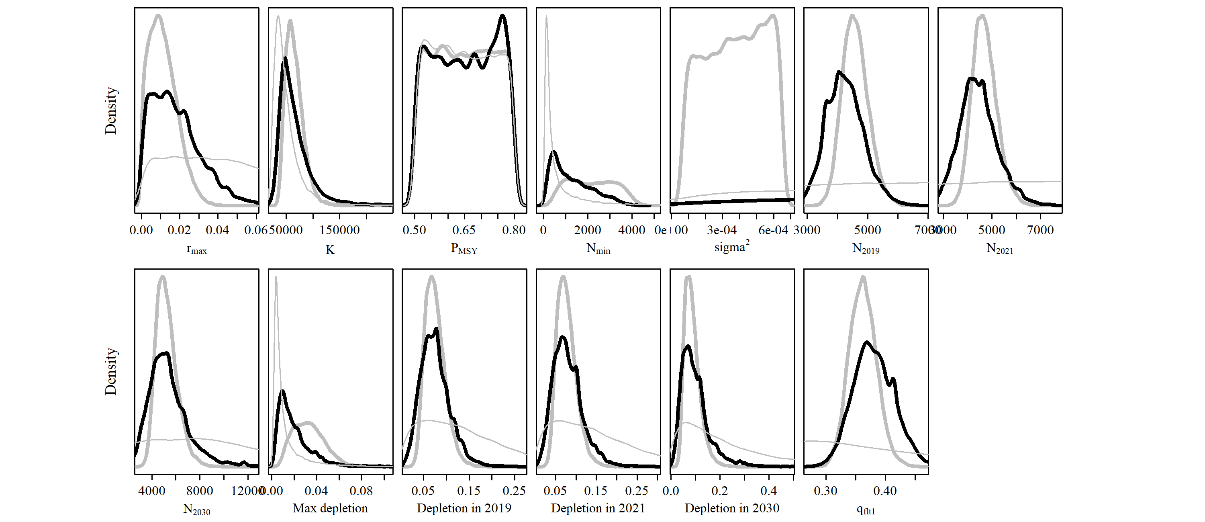

S1.6 Scen 5

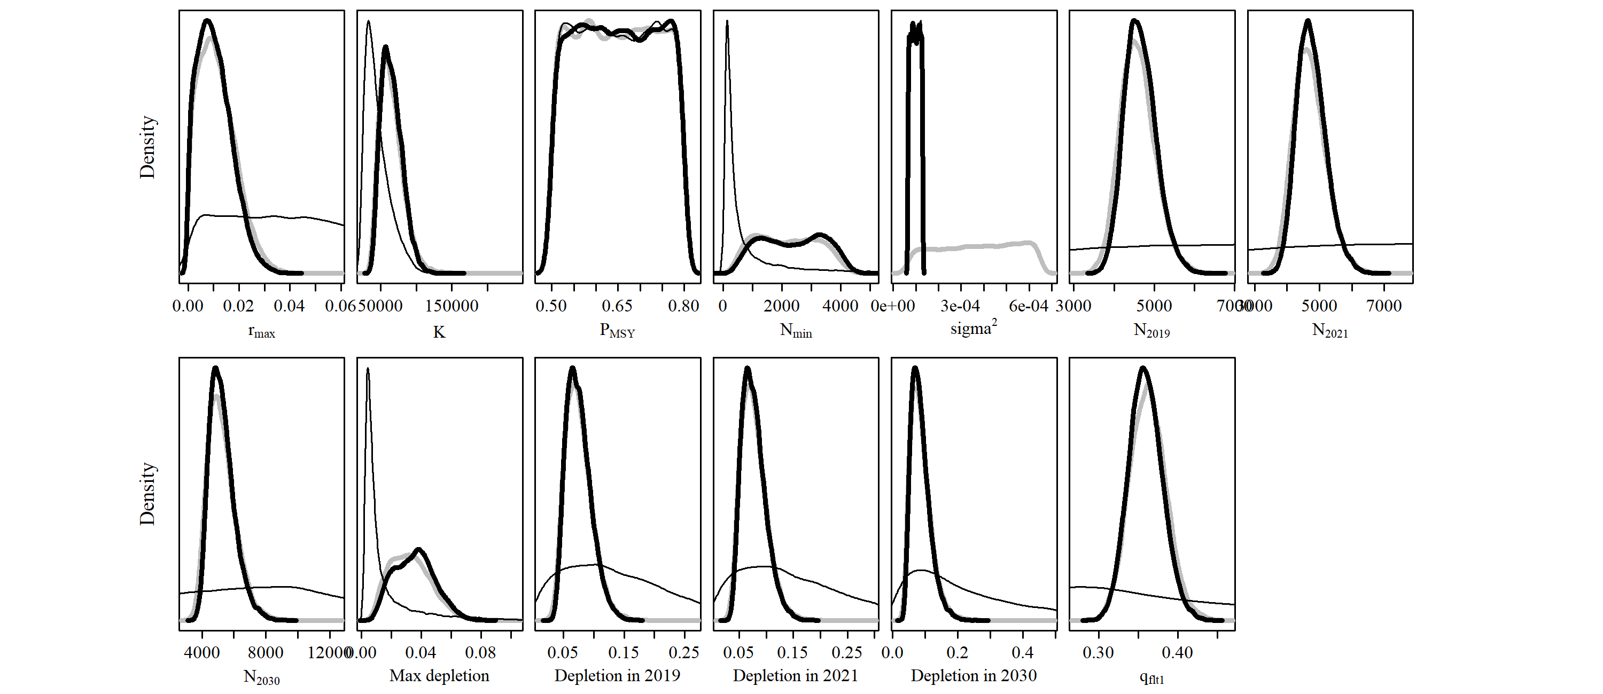

S1.7 Scen 6 (Note: target year is not included)

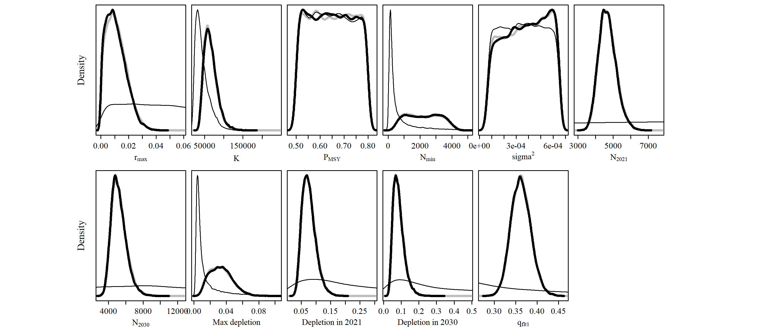

S1.8 Scen 7

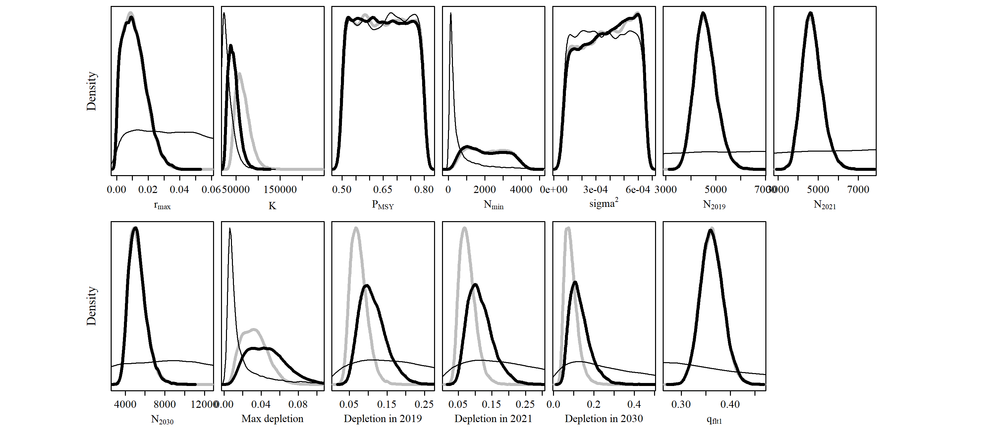

S1.9 Scen 8

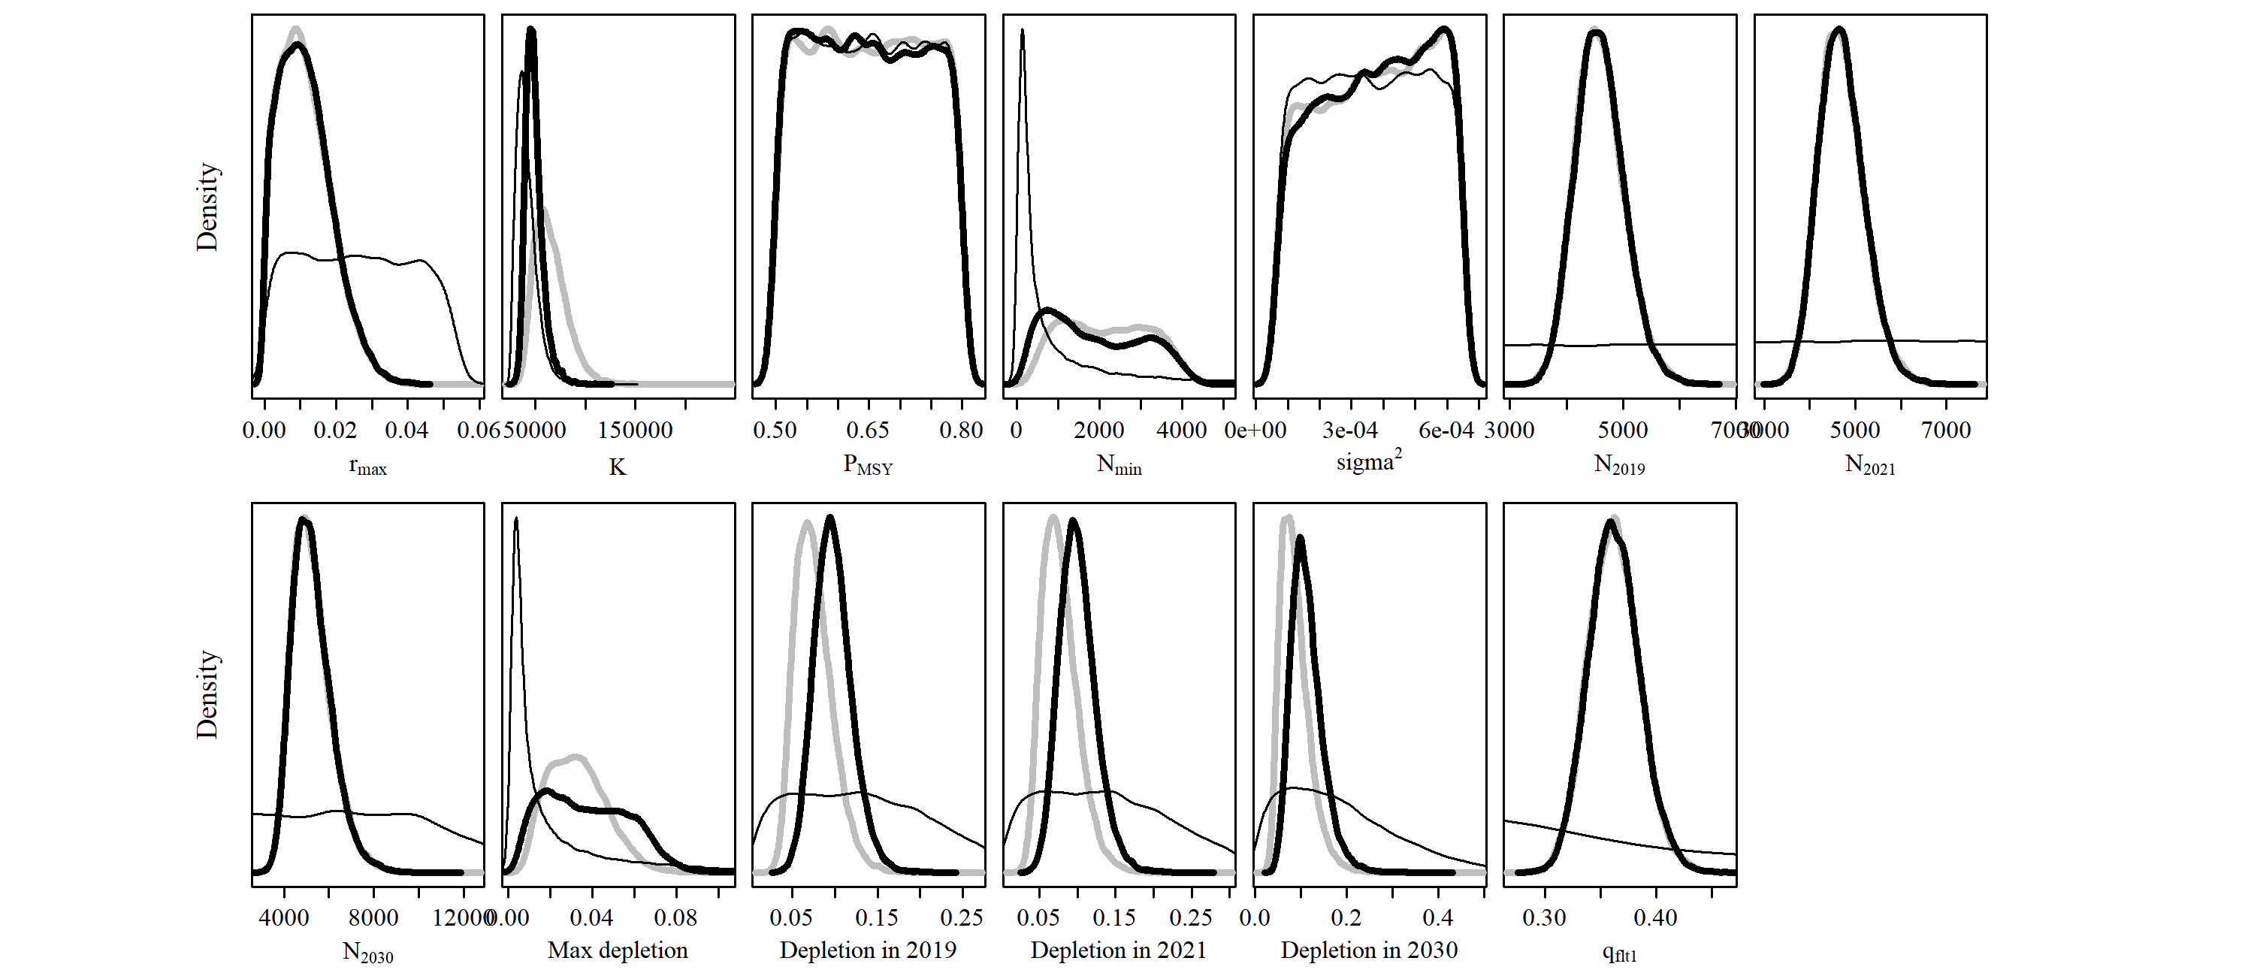

S1.10 Scen 9

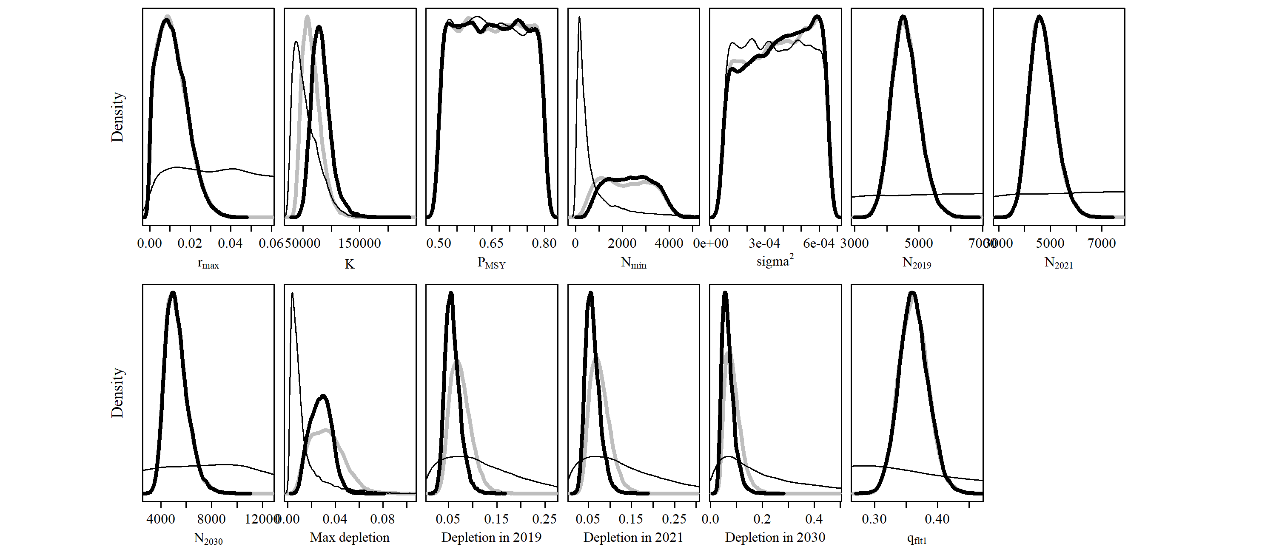

S1.11 Scen 10

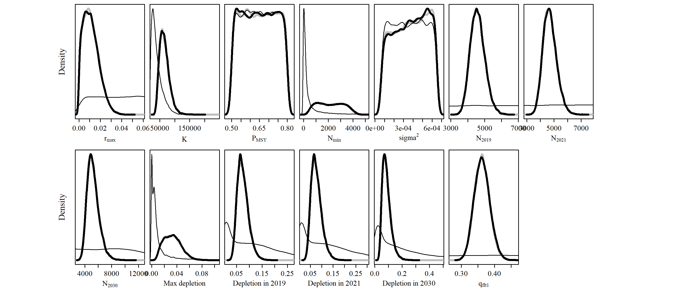

S1.12 Scen 11

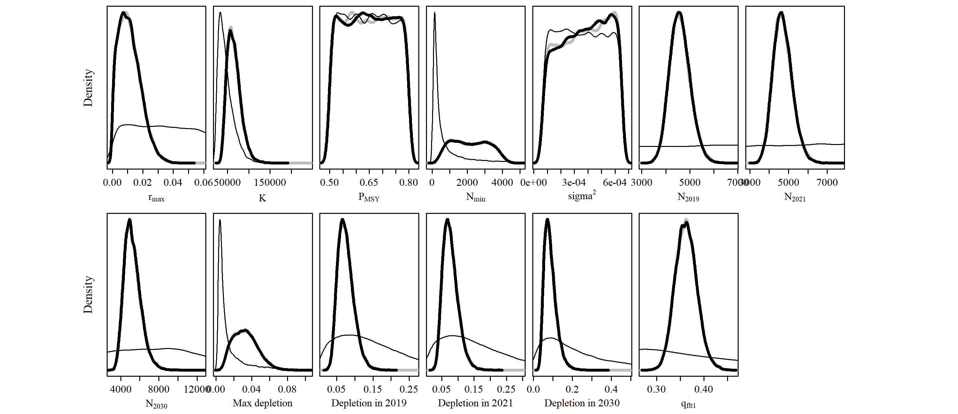

S1.13 Scen 12

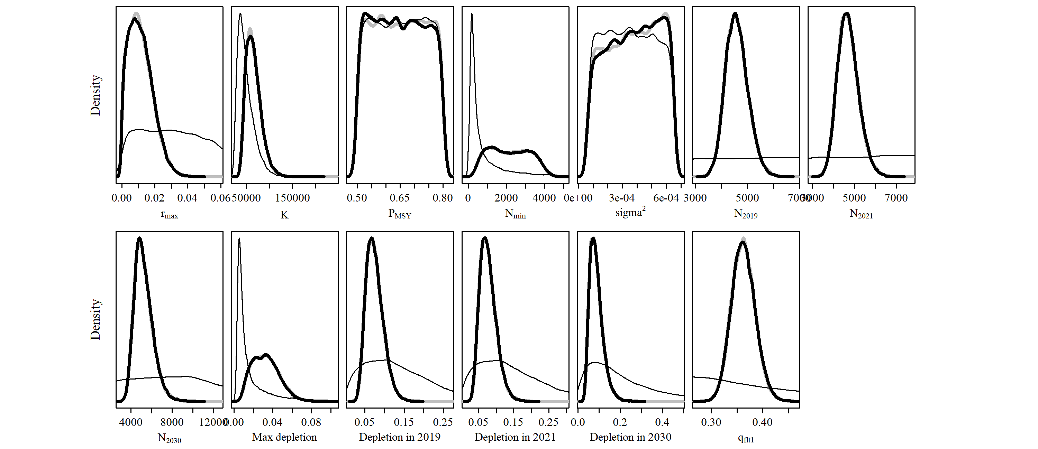

S1.14 Scen 13

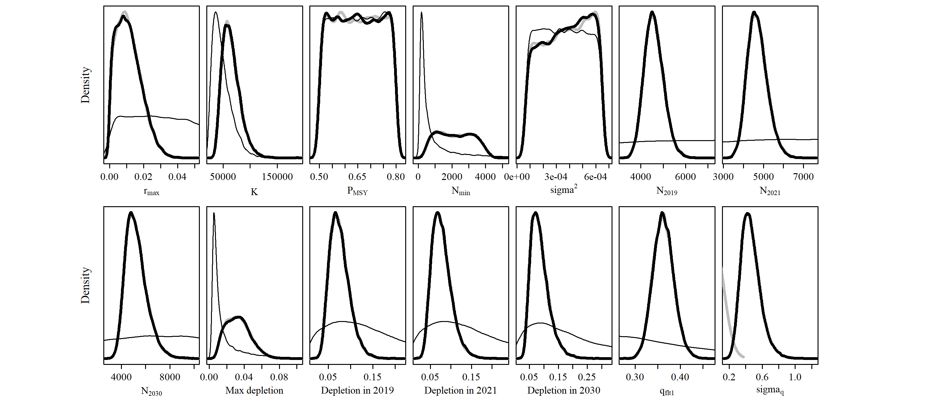

S1.15 Scen 14

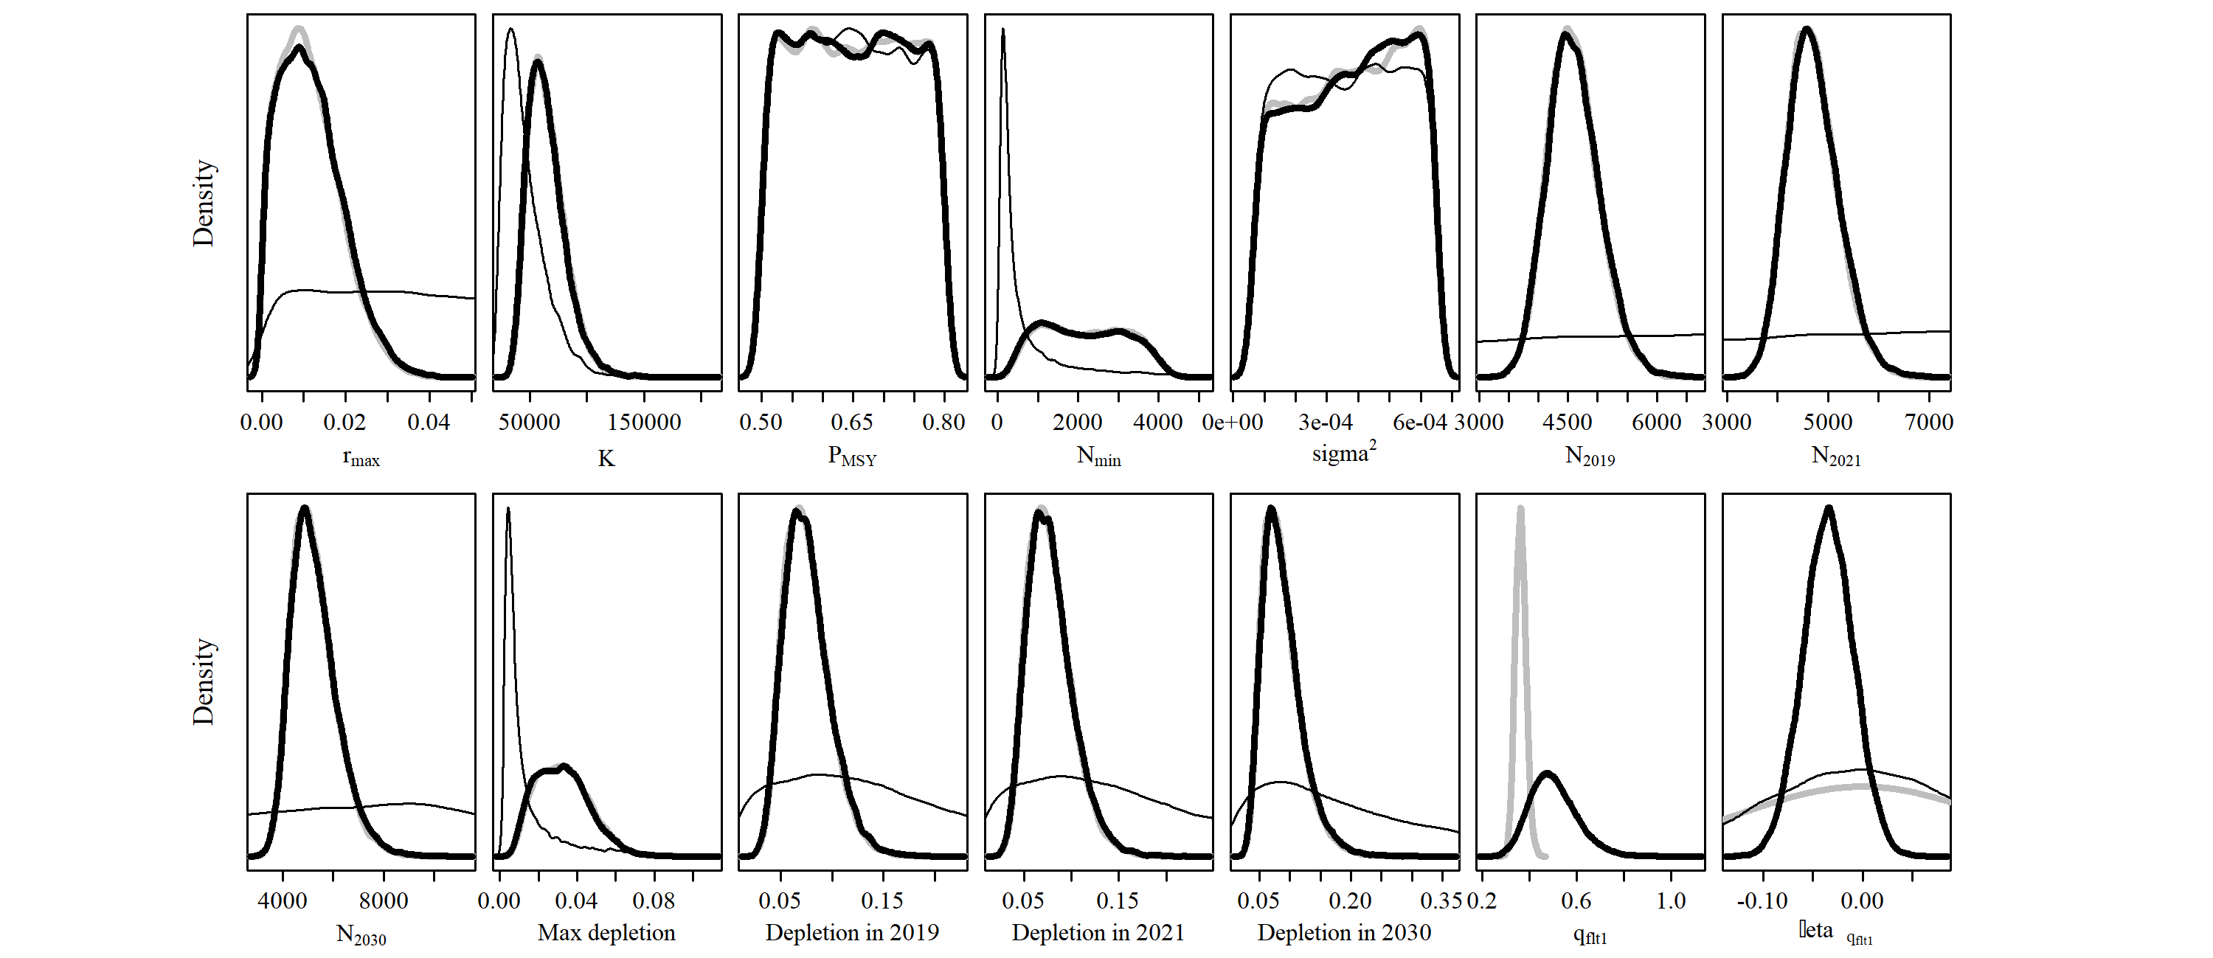

Figure S2. Population trajectories (blue lines) and time series of estimated catches (red lines) of southern right whale (SRW) *Eubalaena australis.* The solid blue line represents the median estimated model-averaged trajectory of the population abundance (), while the shaded areas correspond to the 50% and 95% credible intervals. The dashed line represents the median estimated base case trajectory of the abundance. The solid red line represents the average number of whaling catches as estimated by the catch parameter (), while the red shaded areas correspond to the 50% and 95% credible intervals. The grey and black dots represent the estimated and observed, respectively, absolute abundance in 2010.

S2.1 Base Case

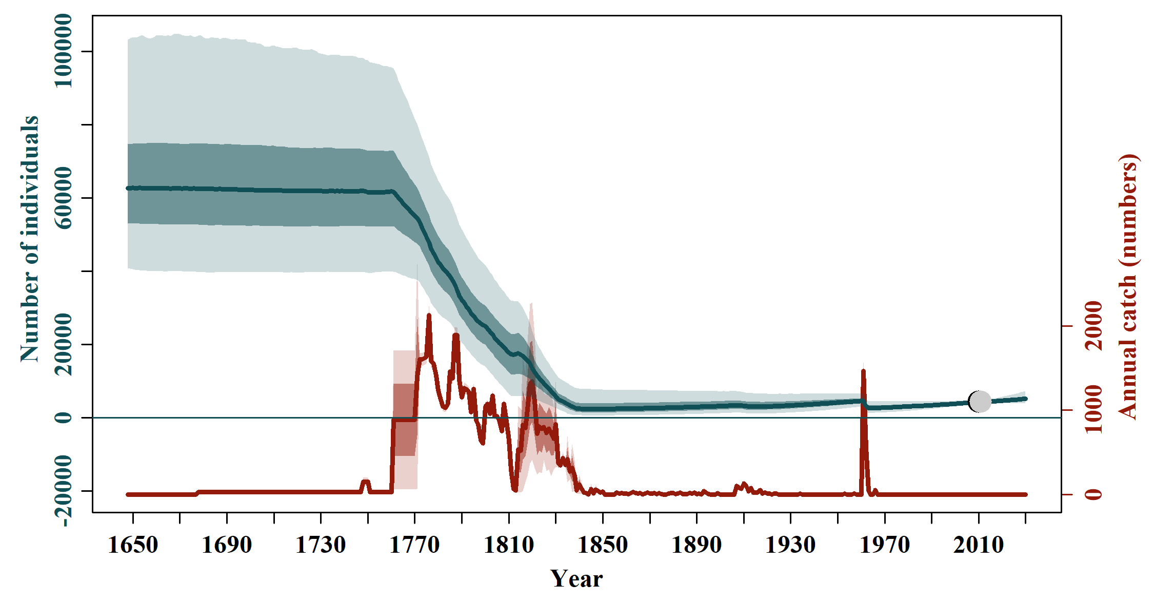

S2.2 Scen 1

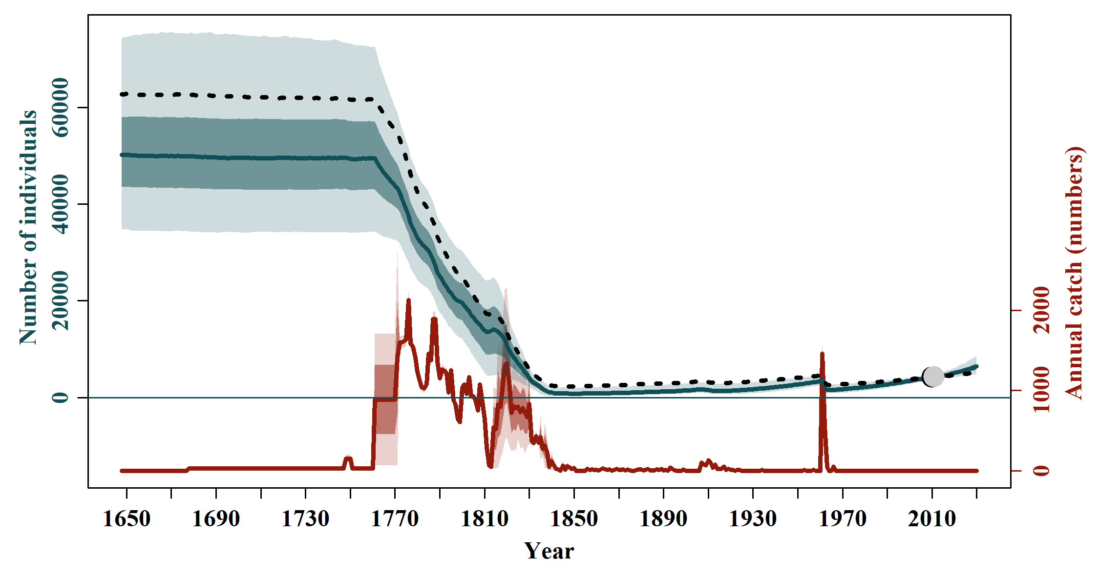

S2.3 Scen 2

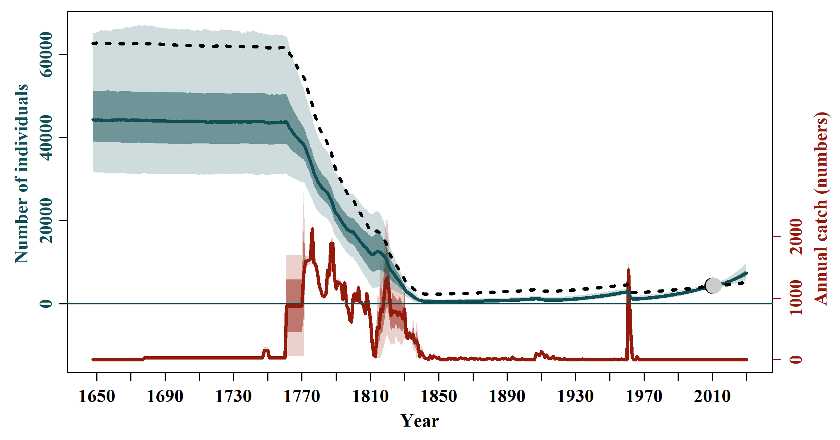

S2.4 Scen 3

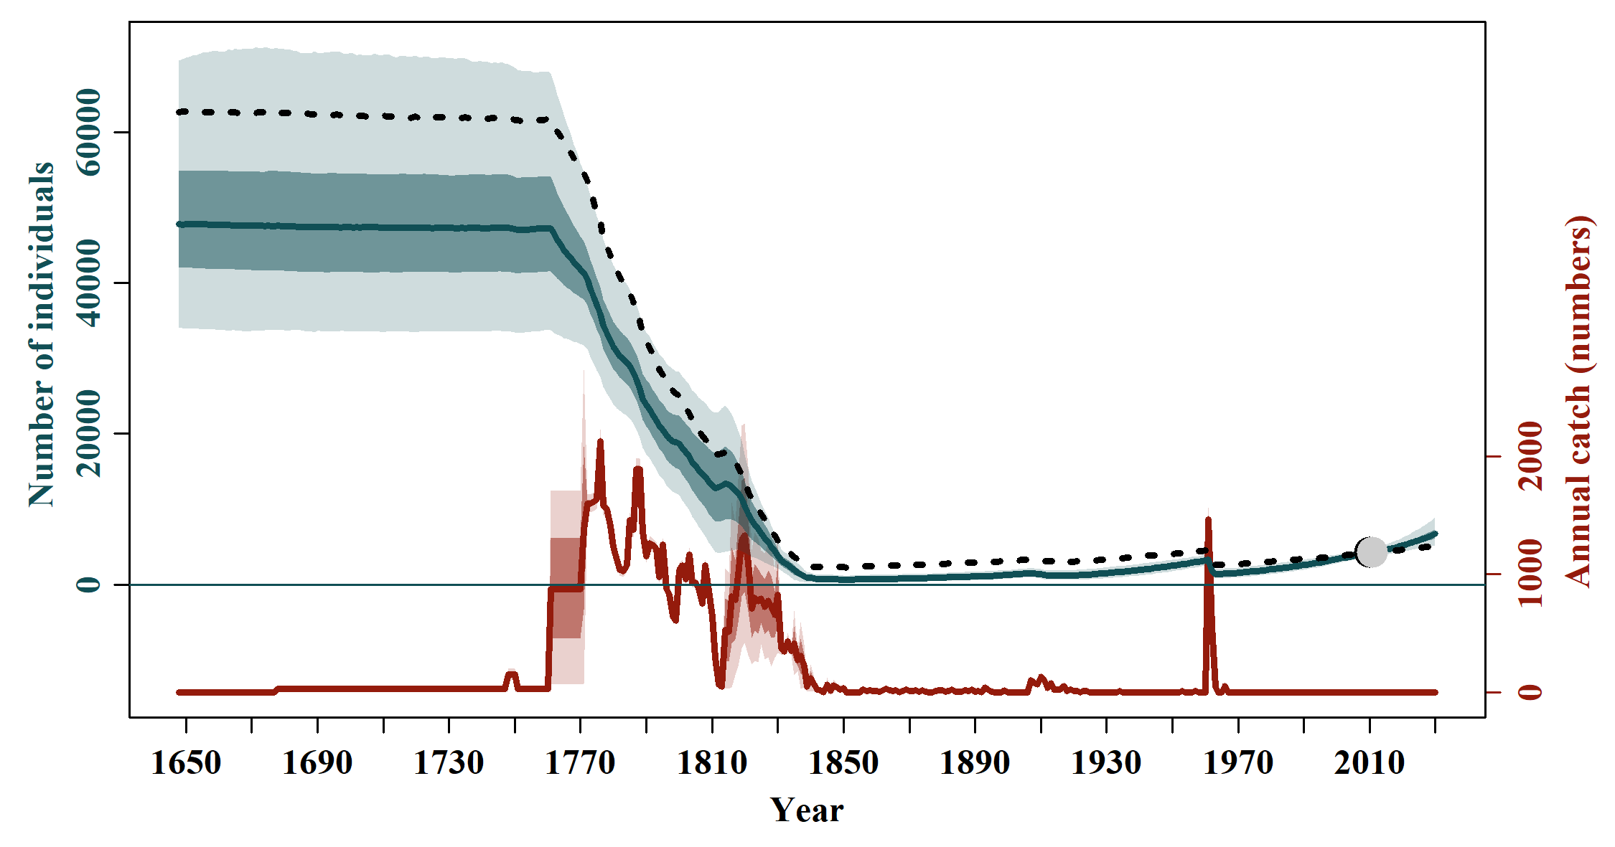

S2.5 Scen 4

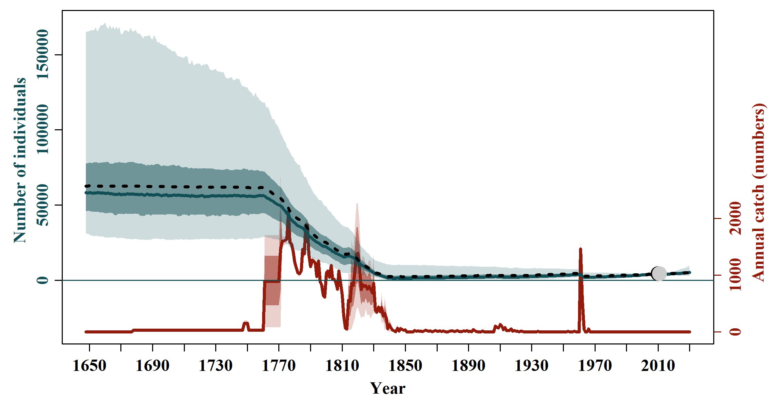

S2.6 Scen 5

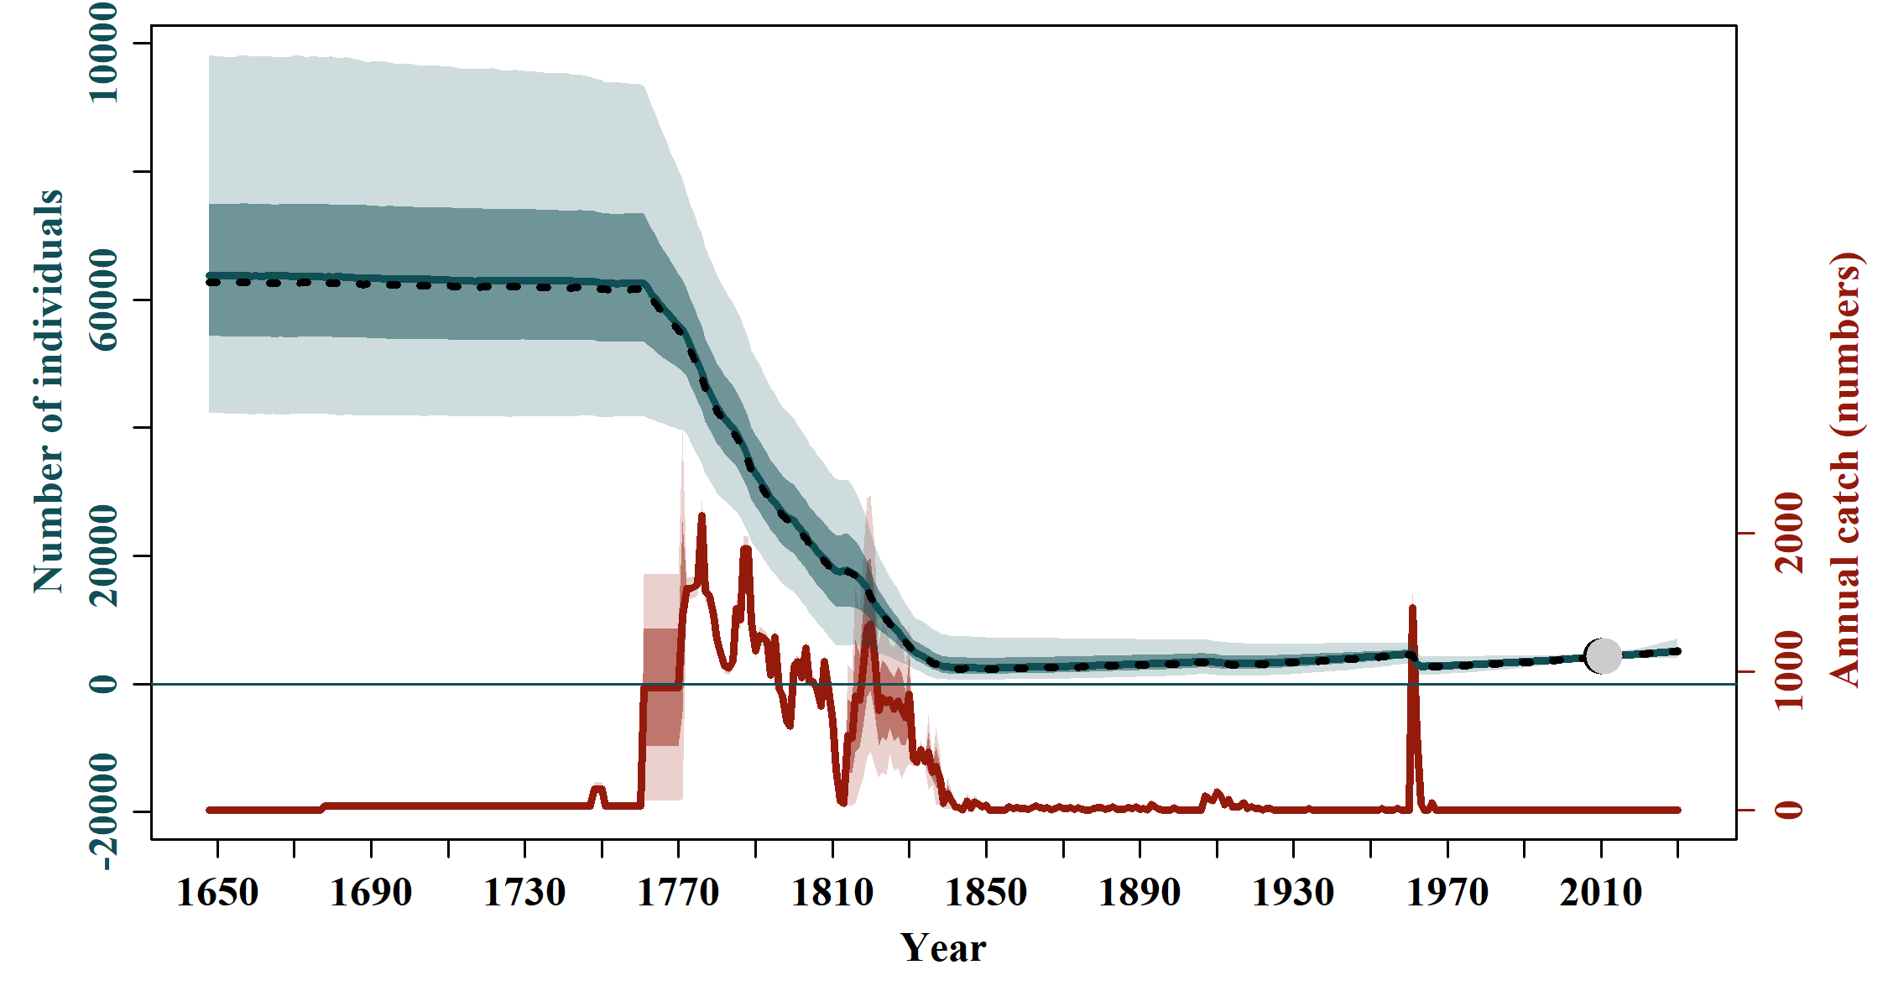

S2.7 Scen 6

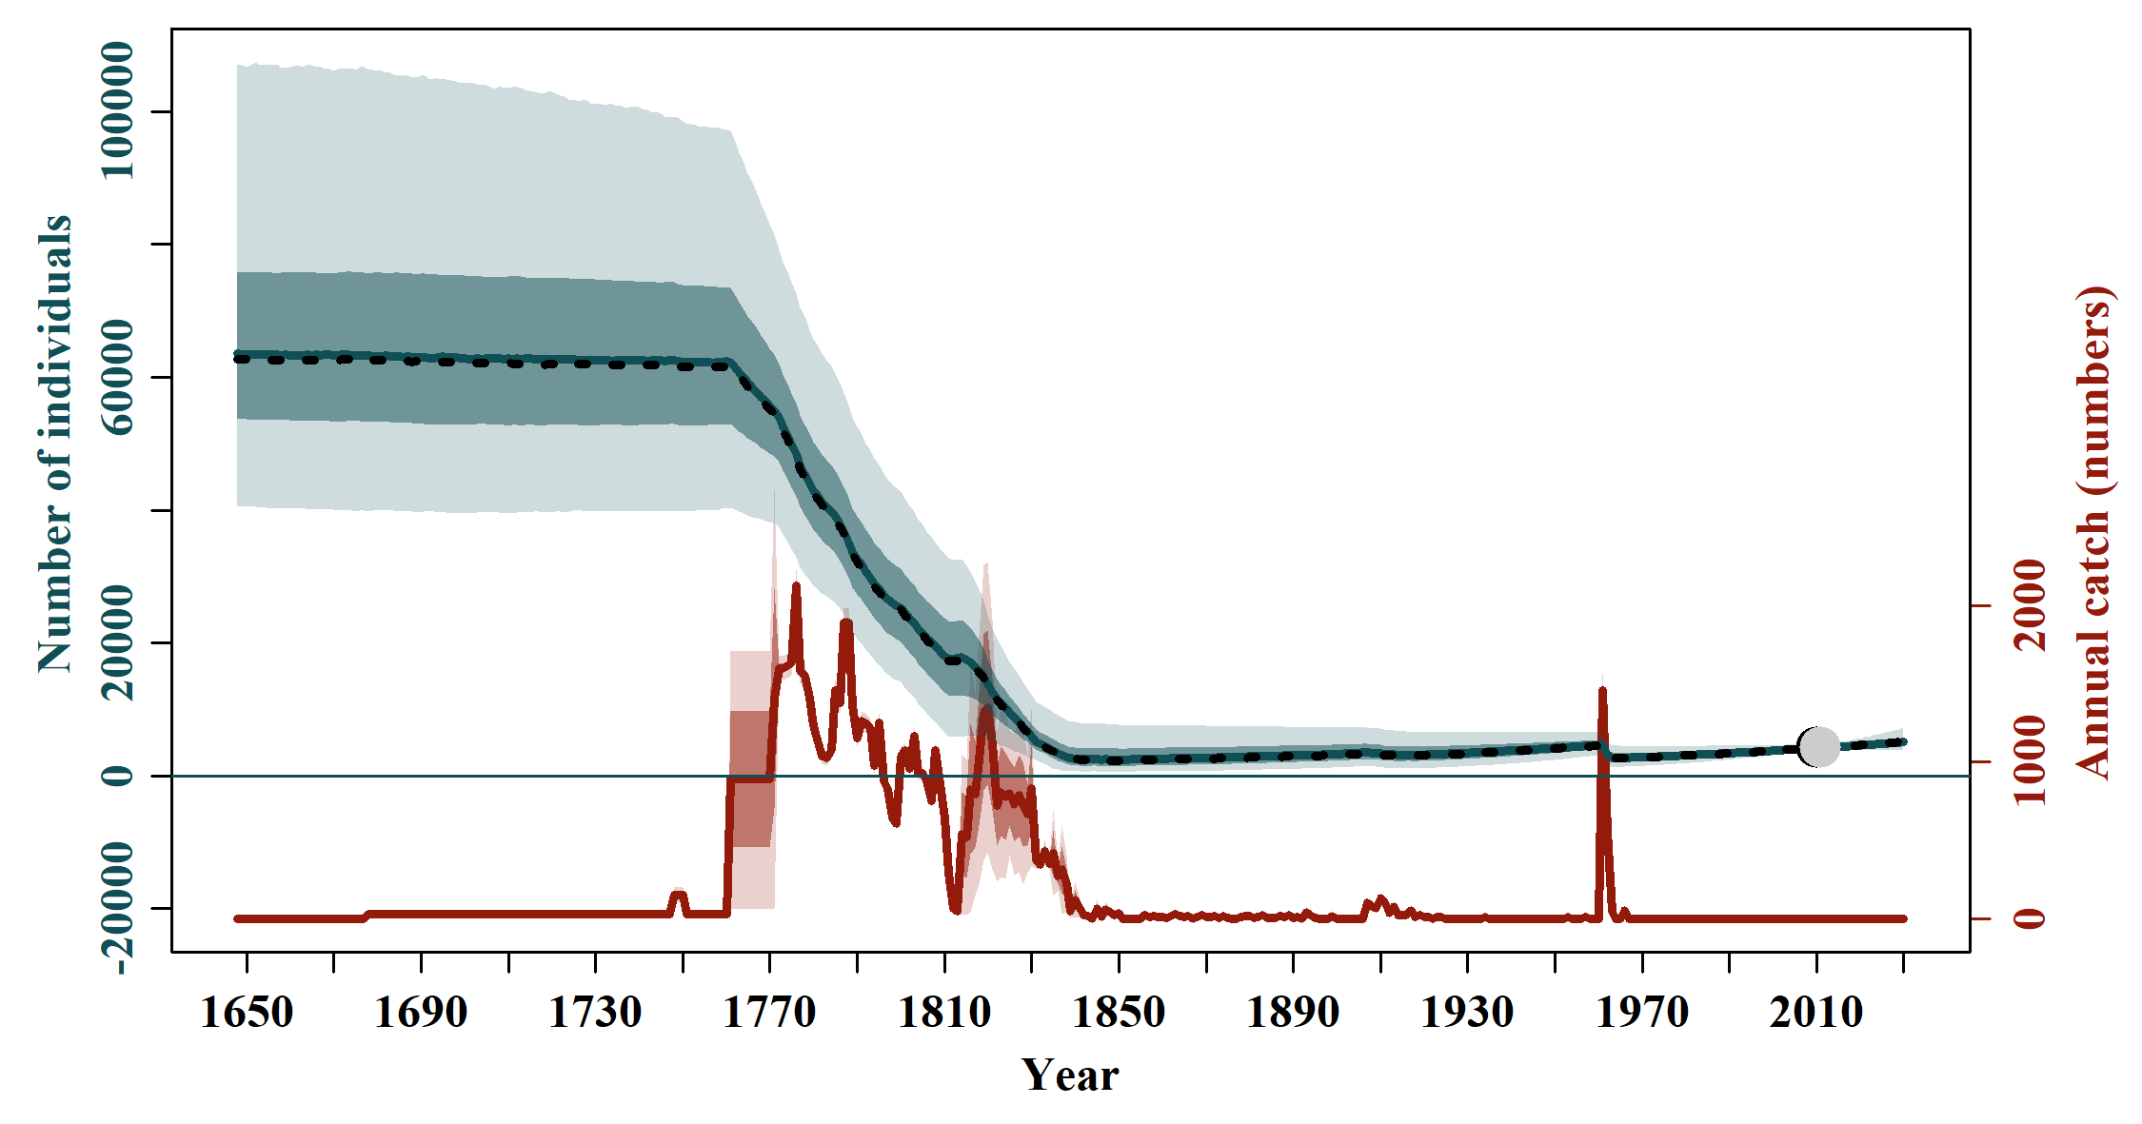

S2.8 Scen 7

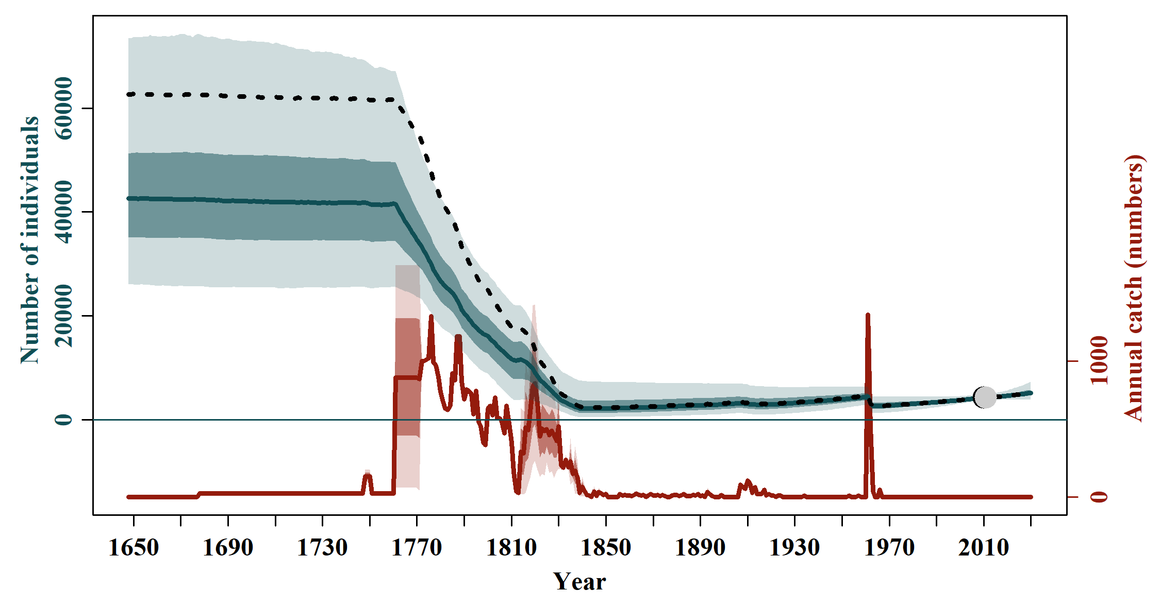

S2.9 Scen 8

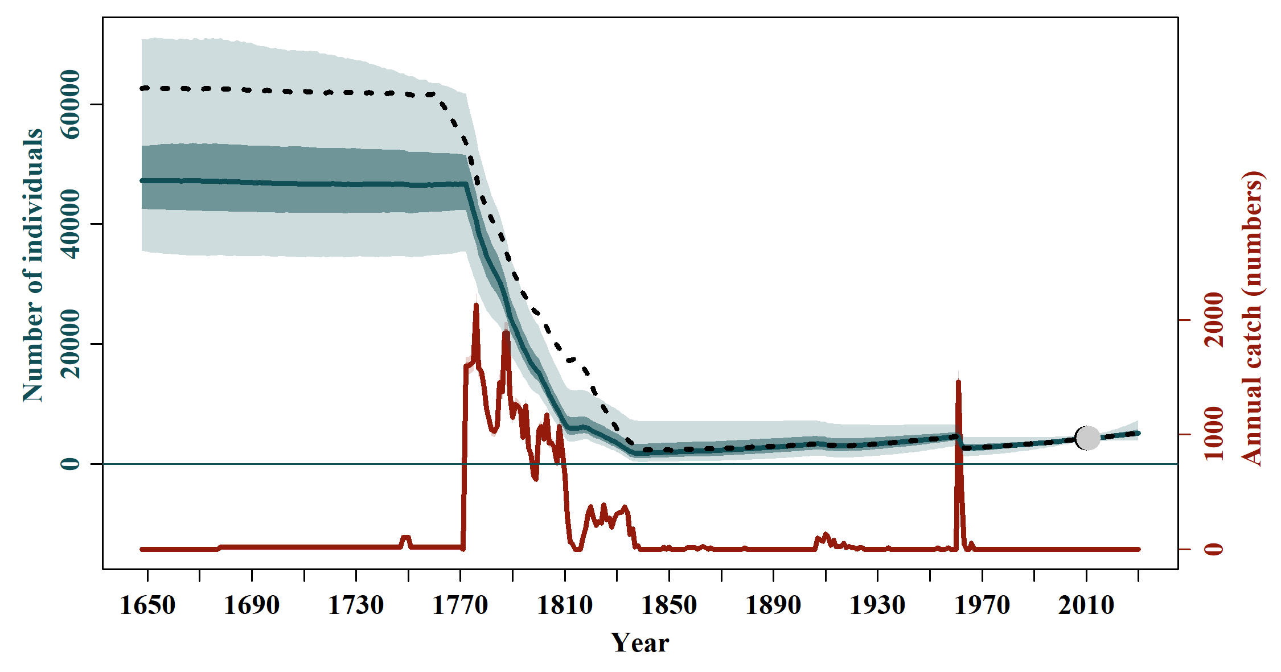

S2.10 Scen 9

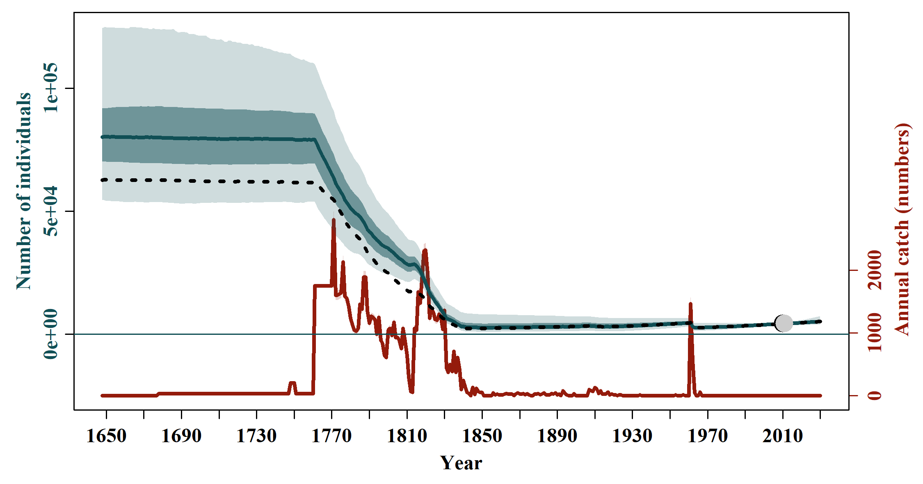

S2.11 Scen 10

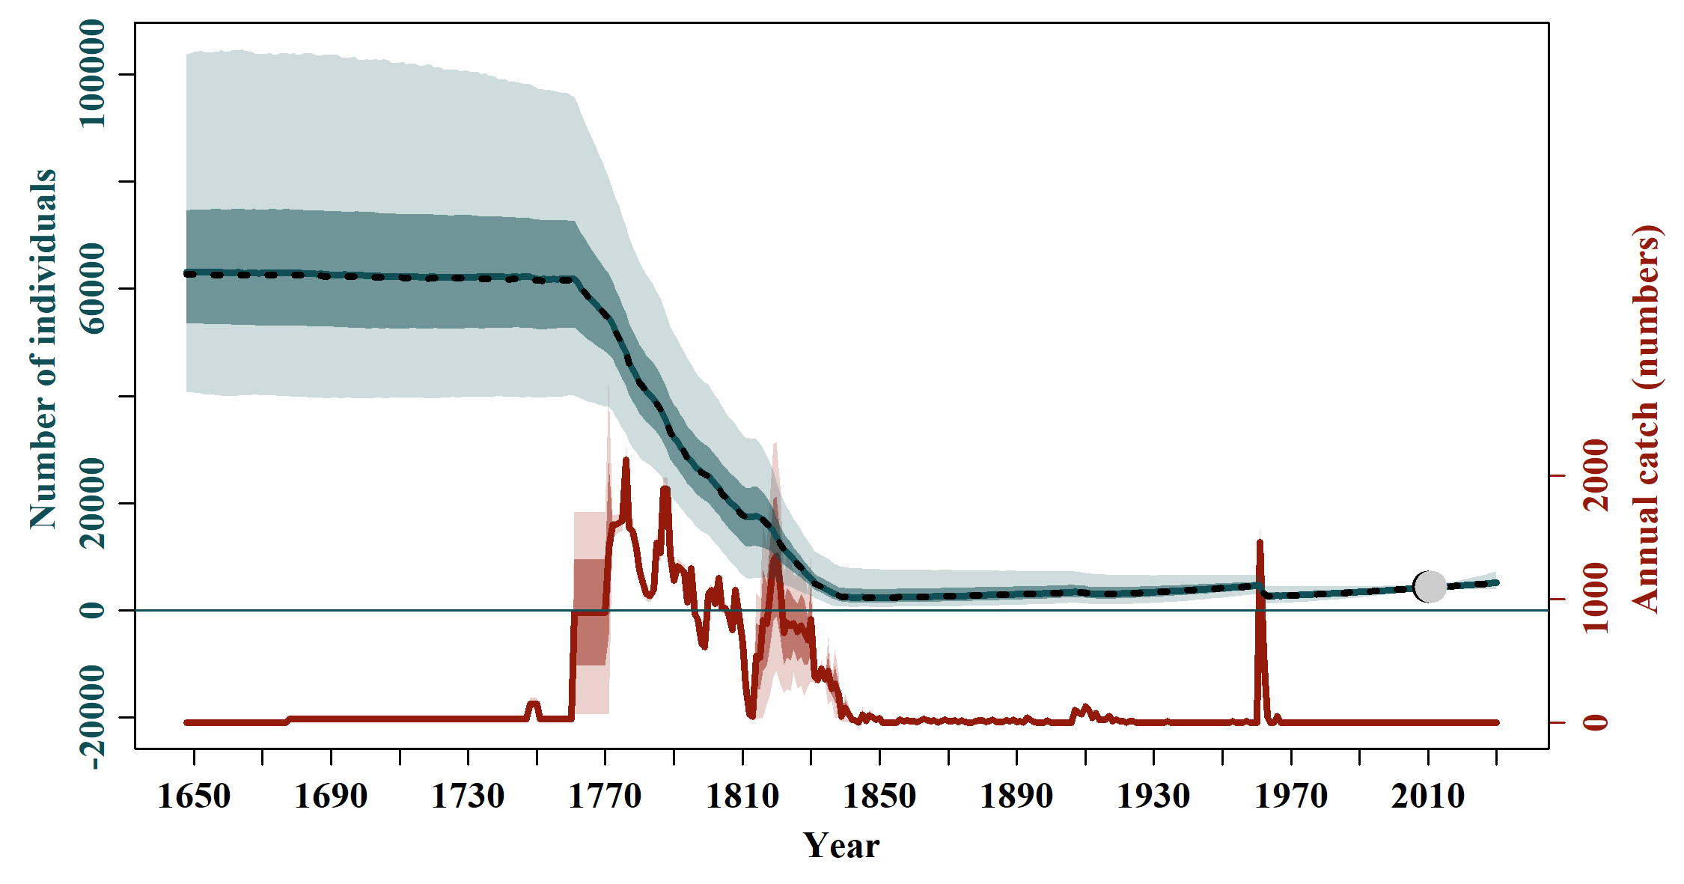

S2.12 Scen 11

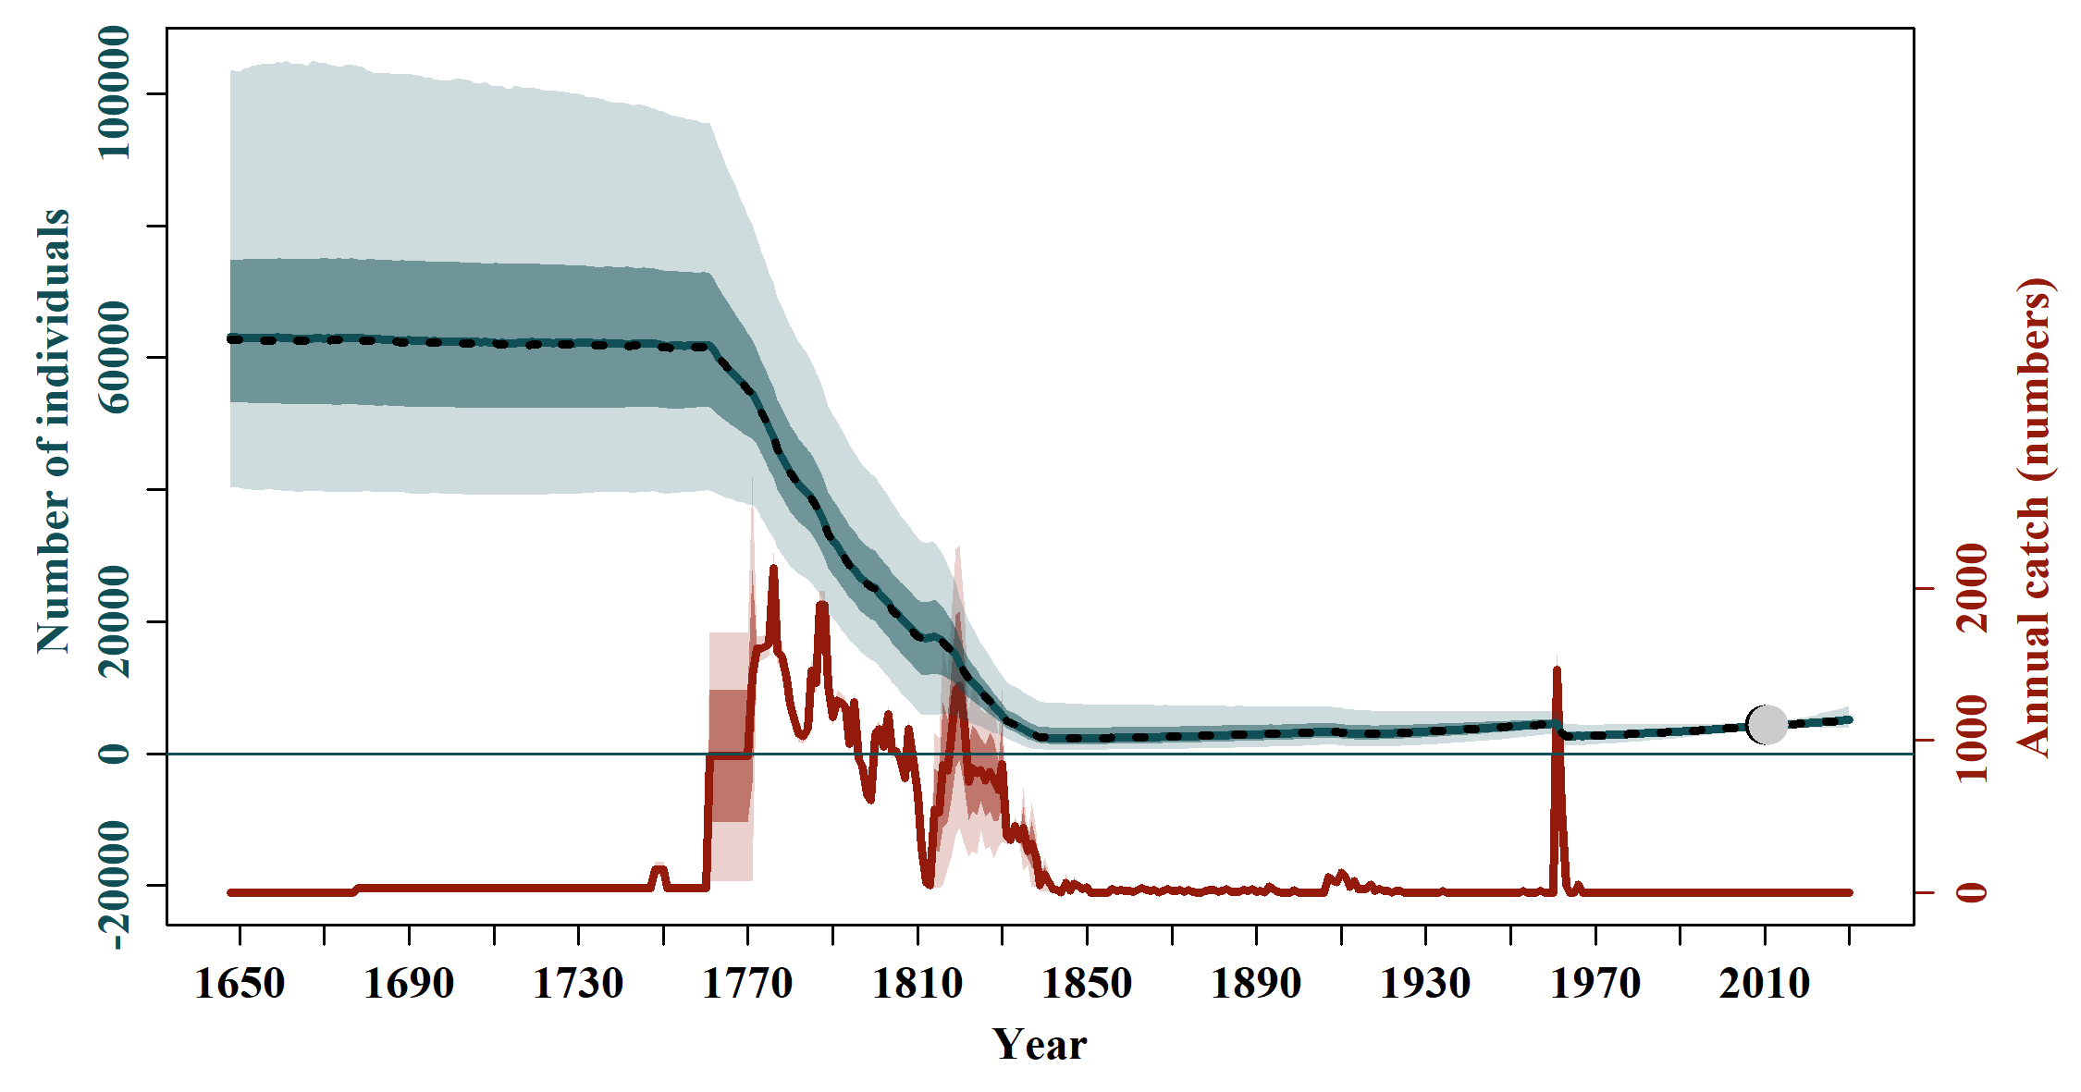

S2.13 Scen 12

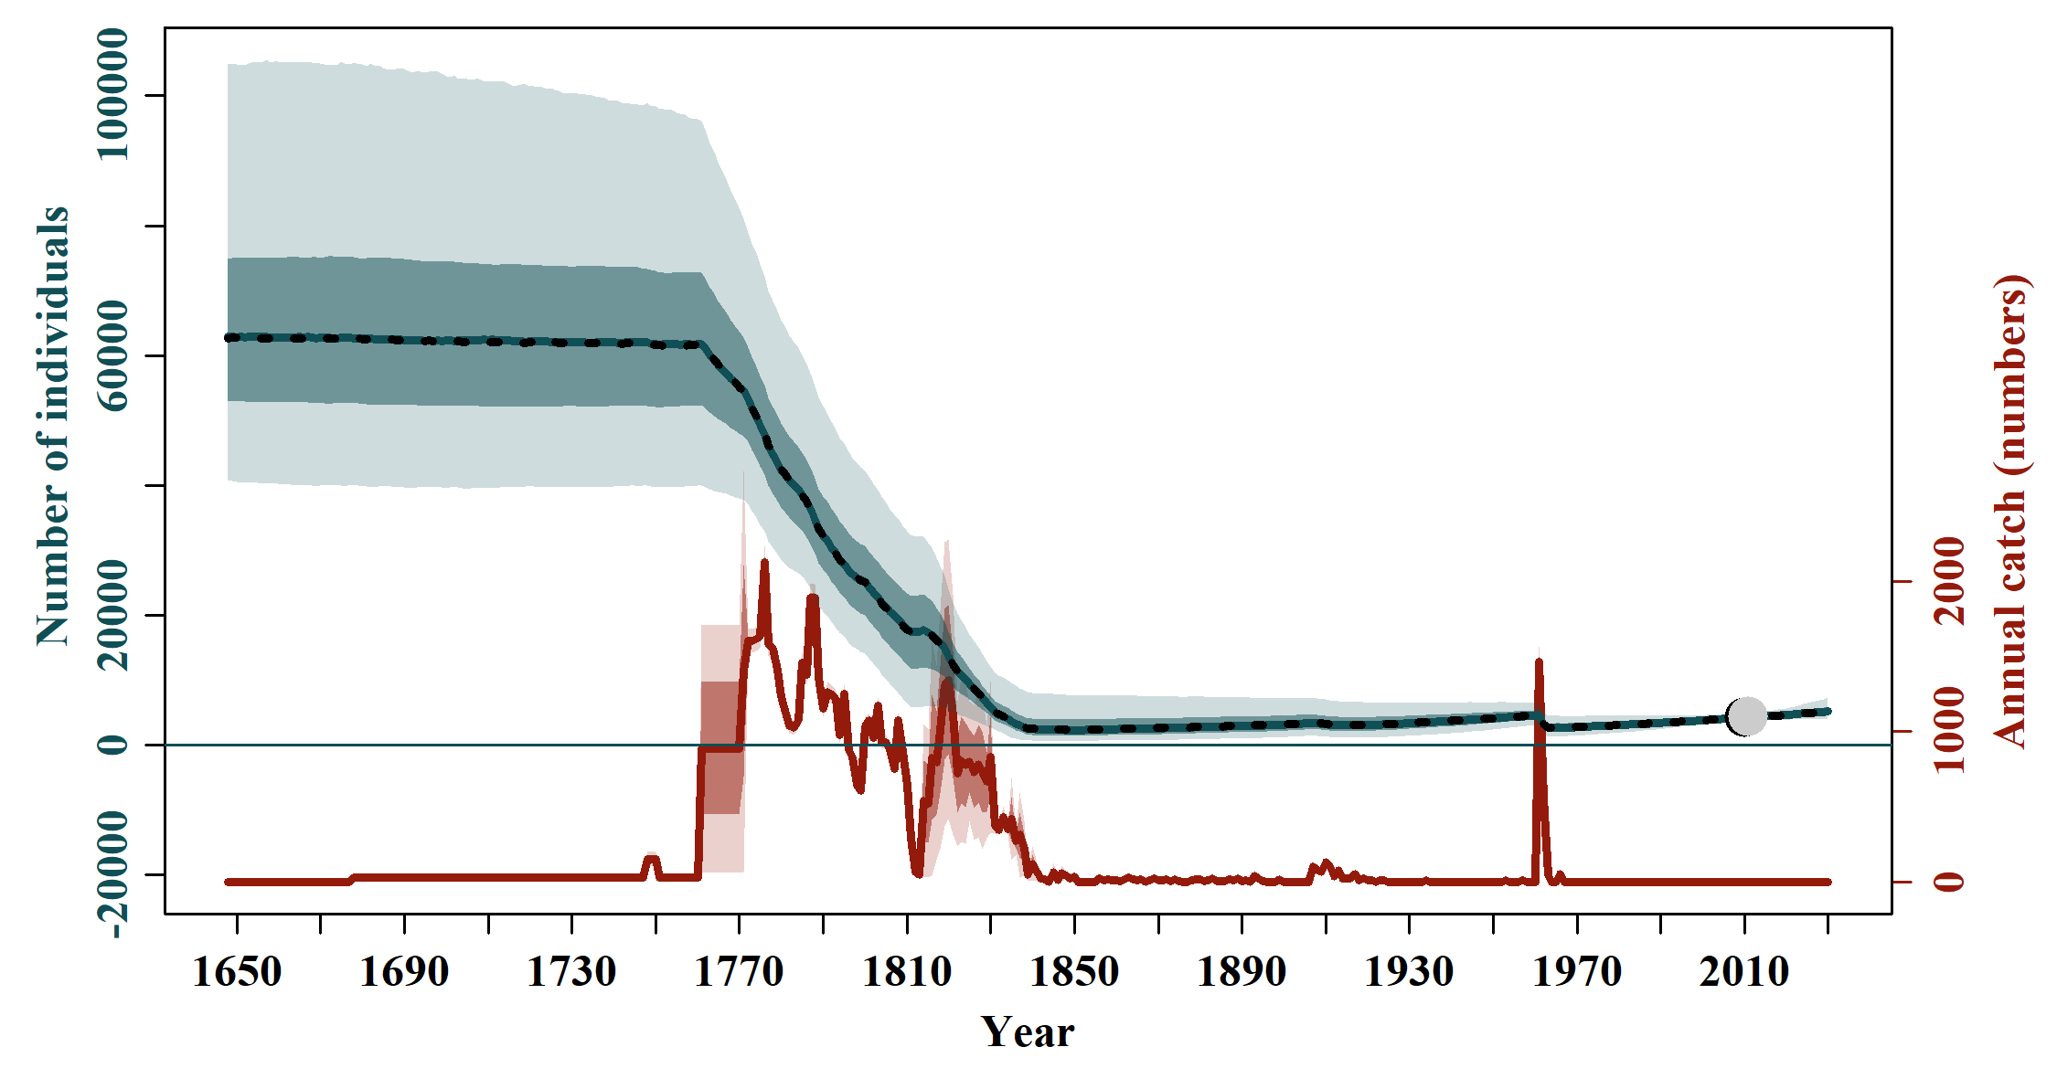

S2.14 Scen 13

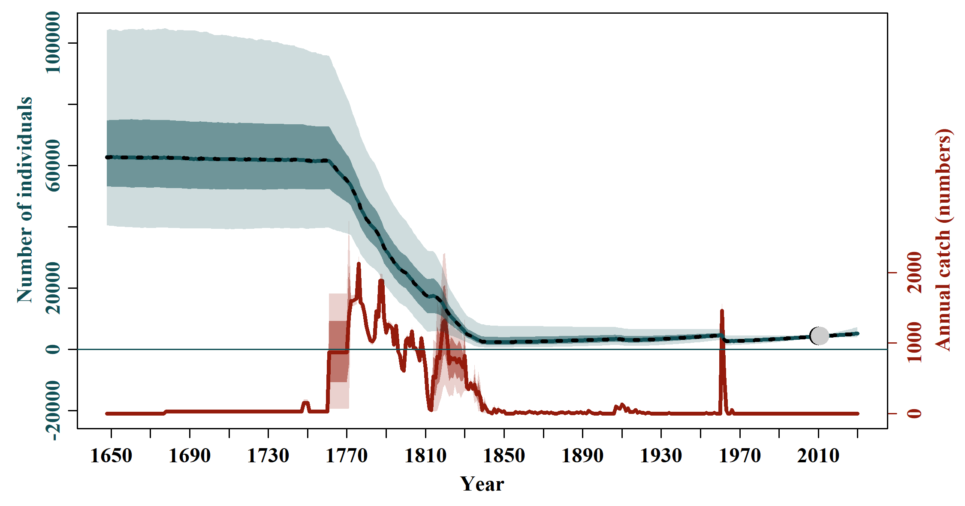

S2.15 Scen 14

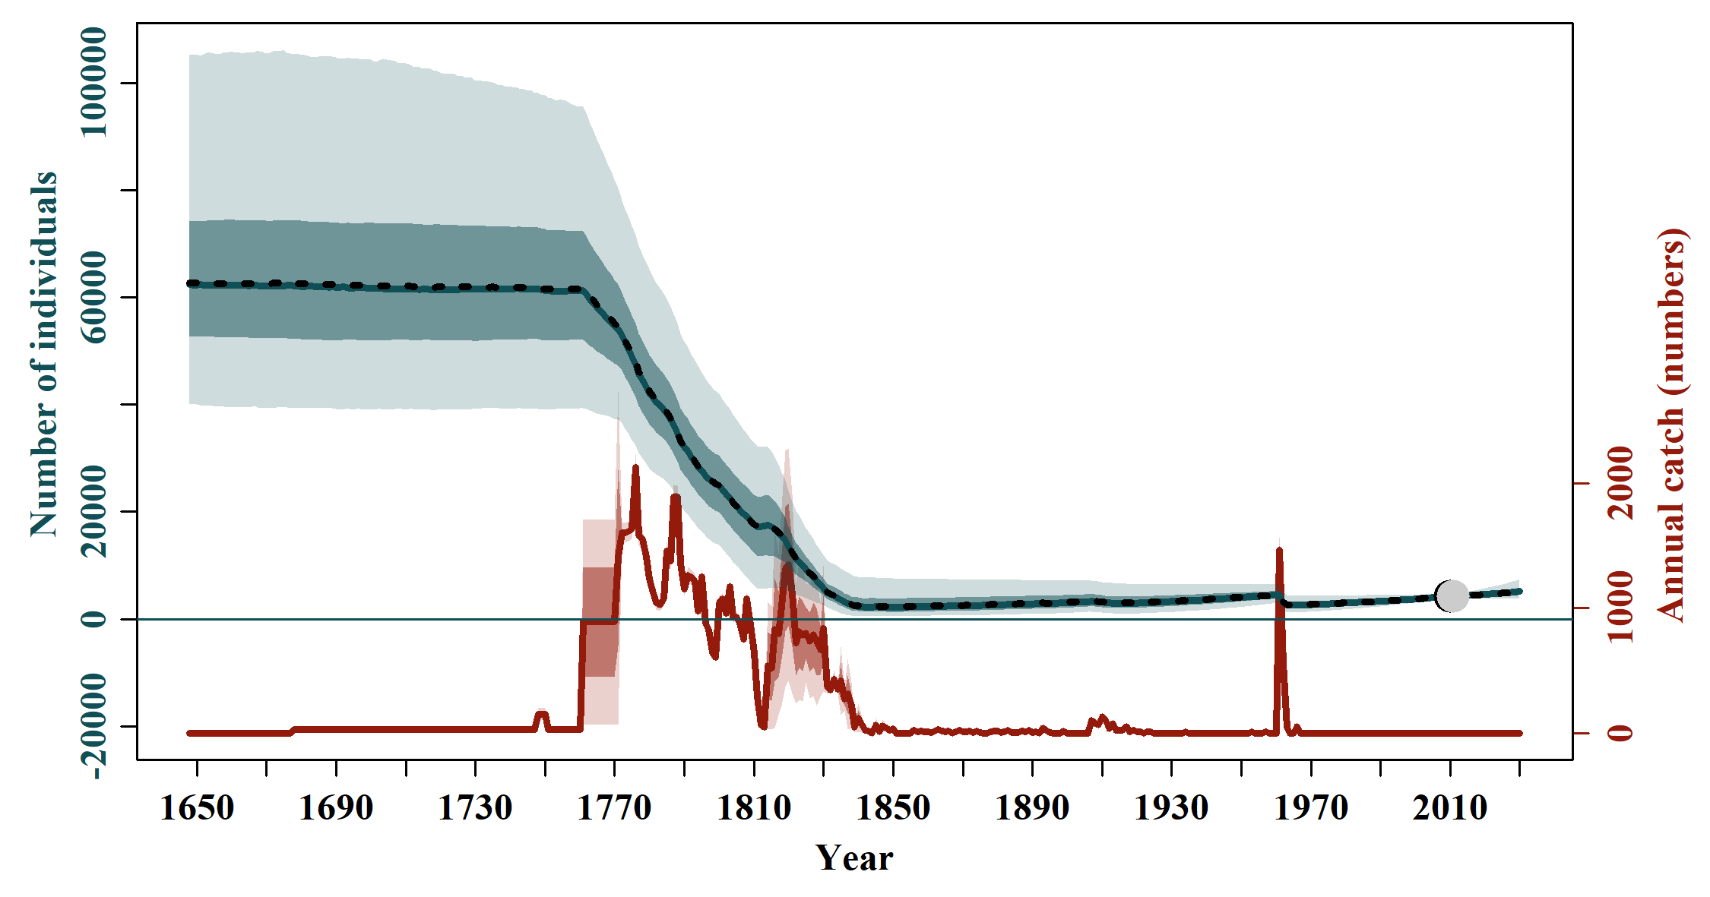

Figure S3. Trend of the observed (black dots) and estimated (grey dots) accumulated numbers of the southern right whale Eubalaena australis and associated 95% confidence interval. The solid blue line represents the median estimated model-averaged trajectory of the population abundance (N_y) multiplied by catchability (q), while the shaded areas correspond to the 50% and 95% credible intervals.

S3.1 Base Case

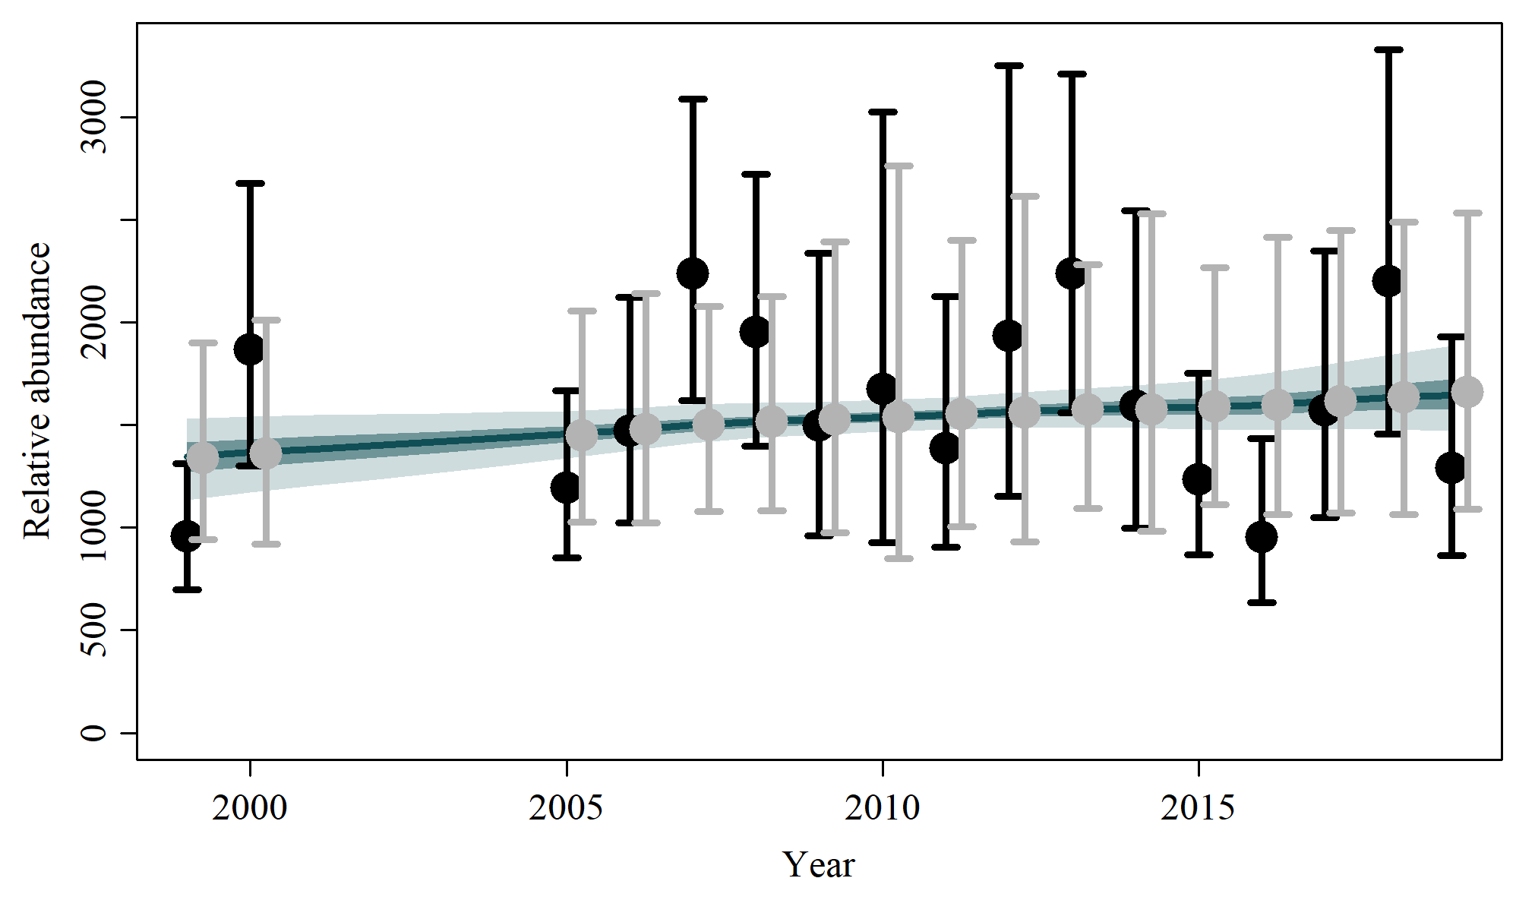

S3.2 Scen 1

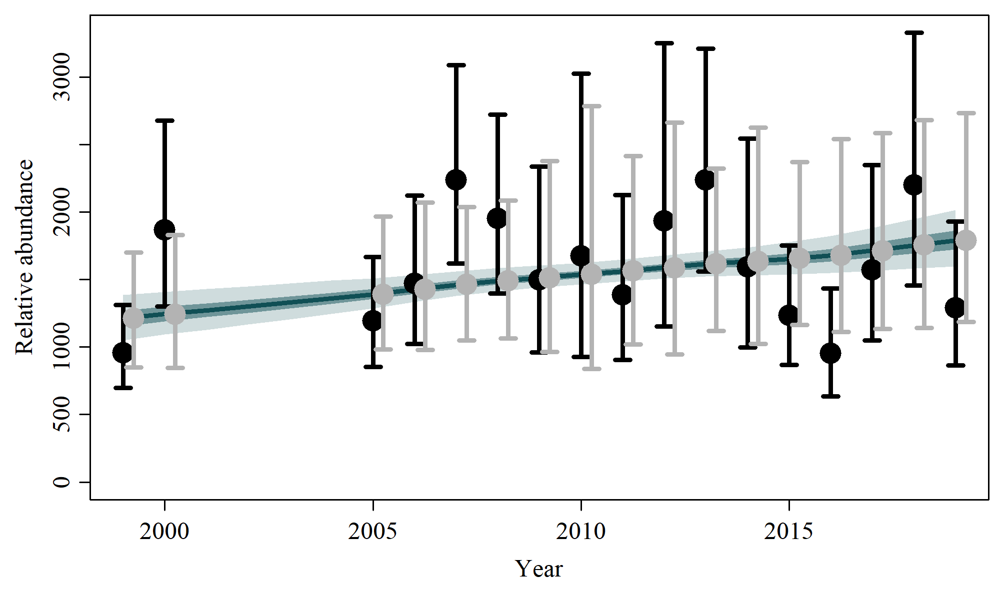

S3.3 Scen 2

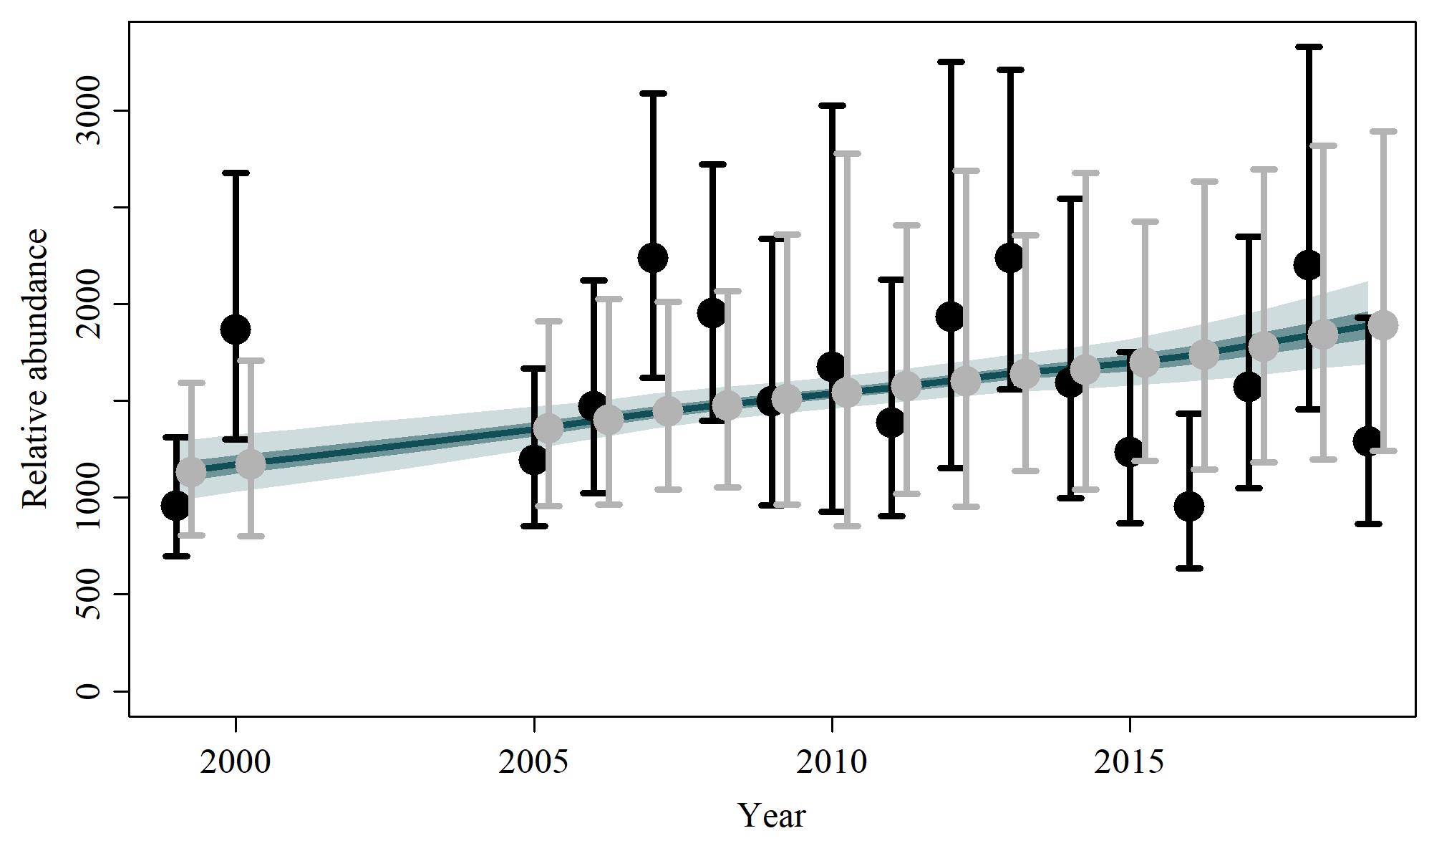

S3.4 Scen 3

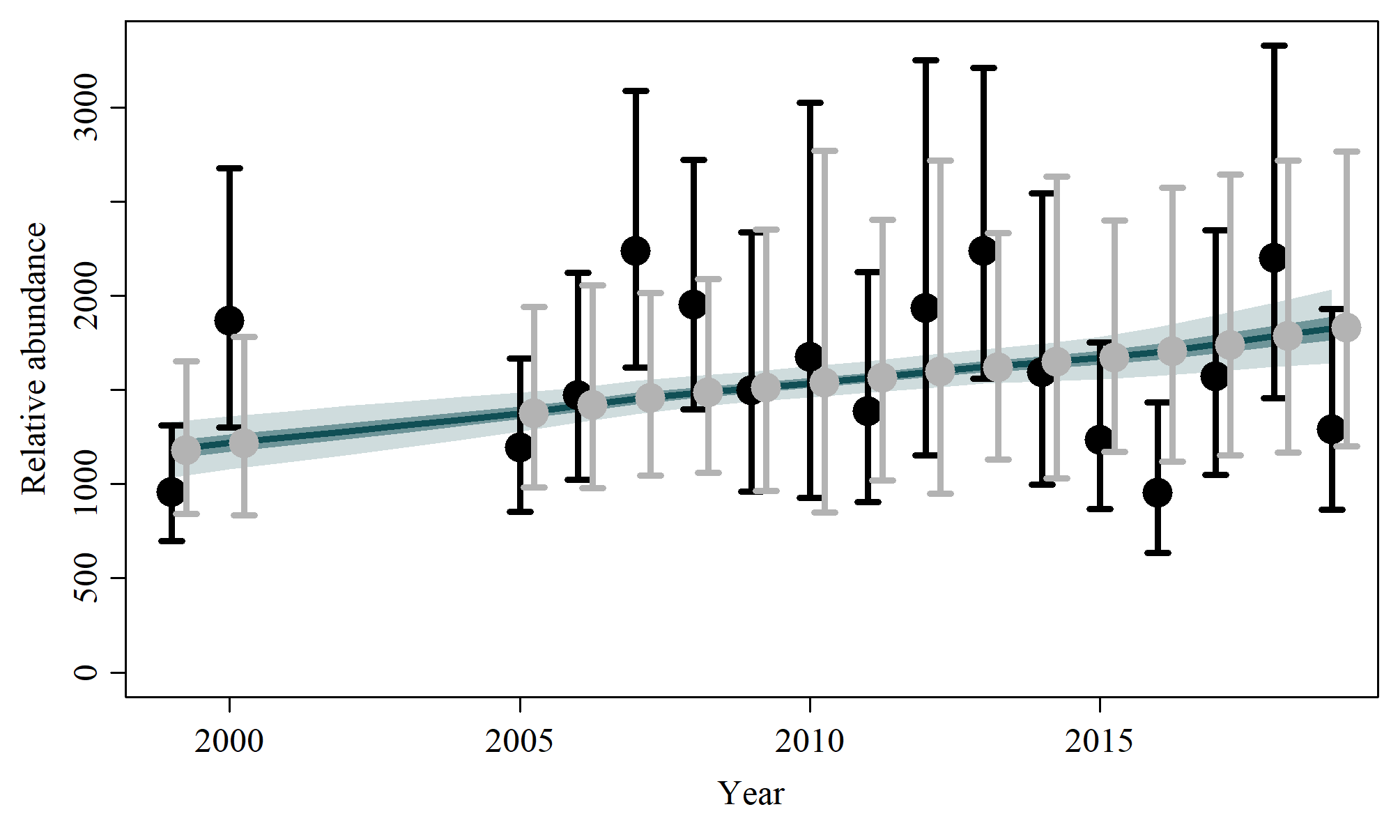

S3.5 Scen 4

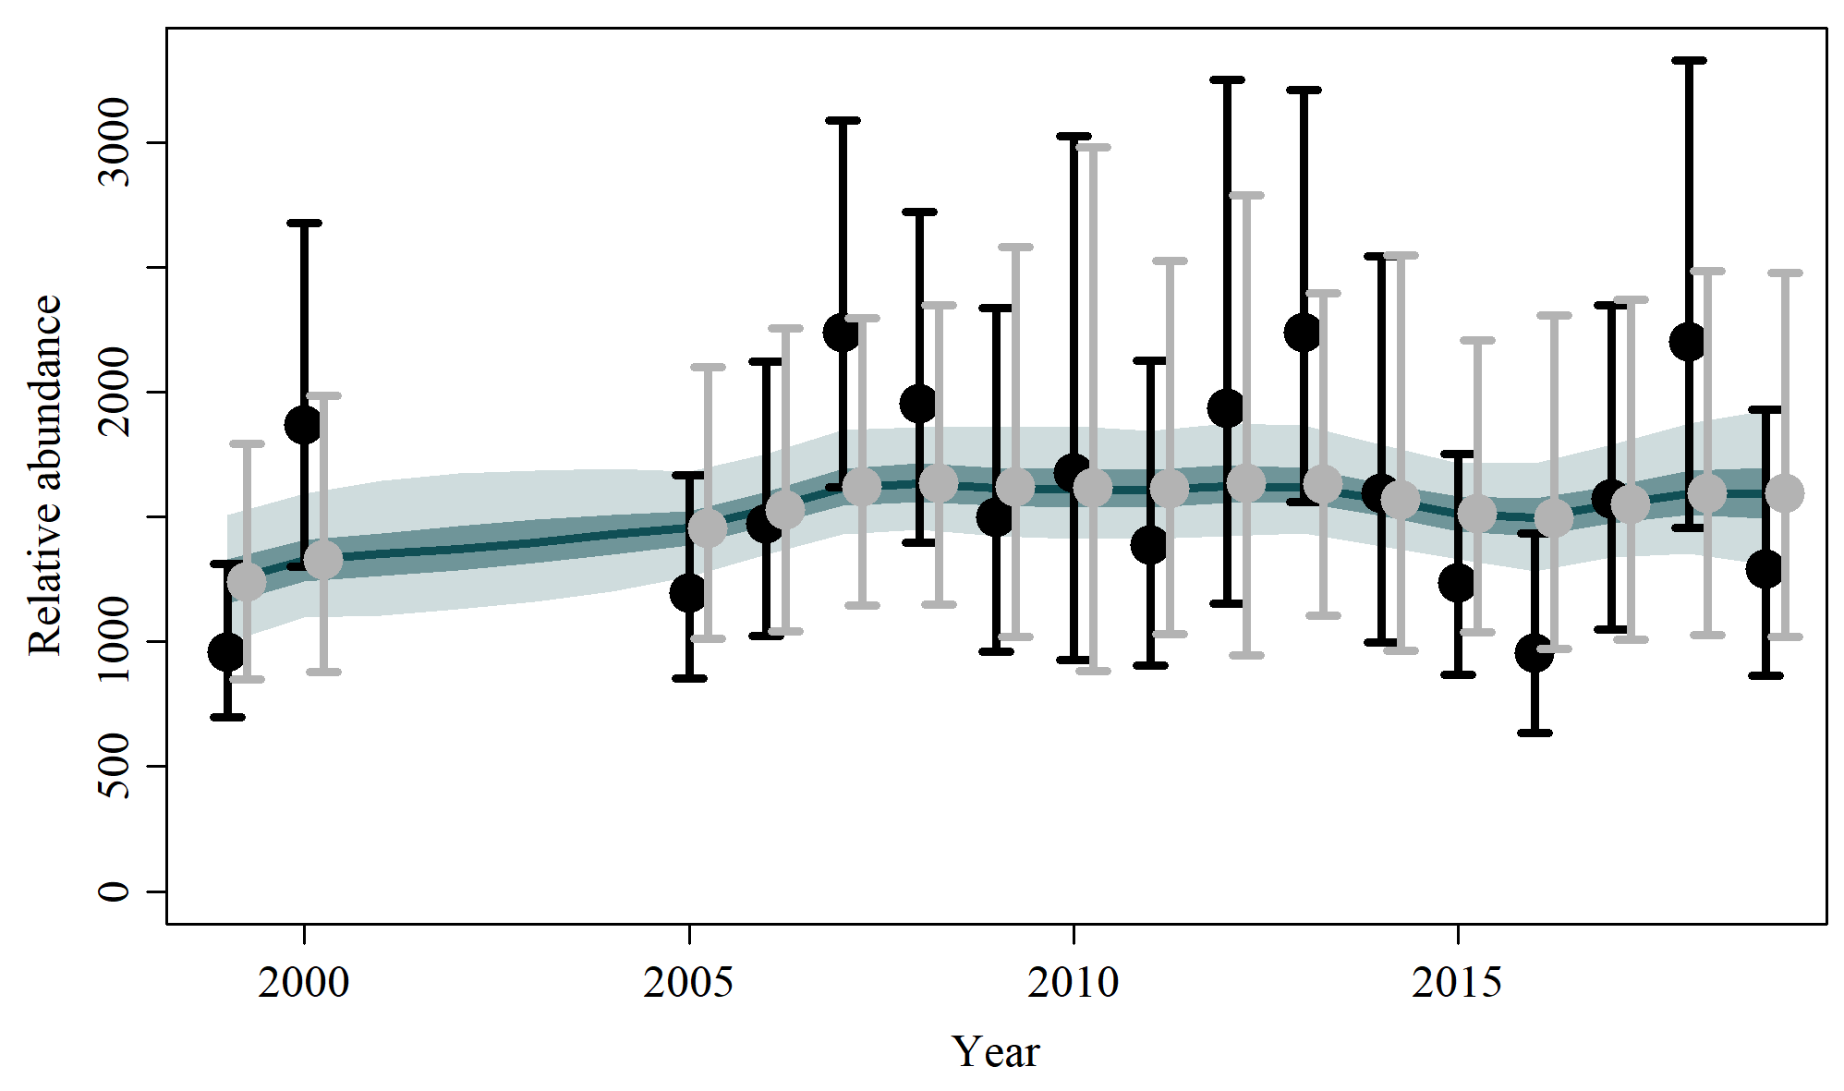

S3.6 Scen 5

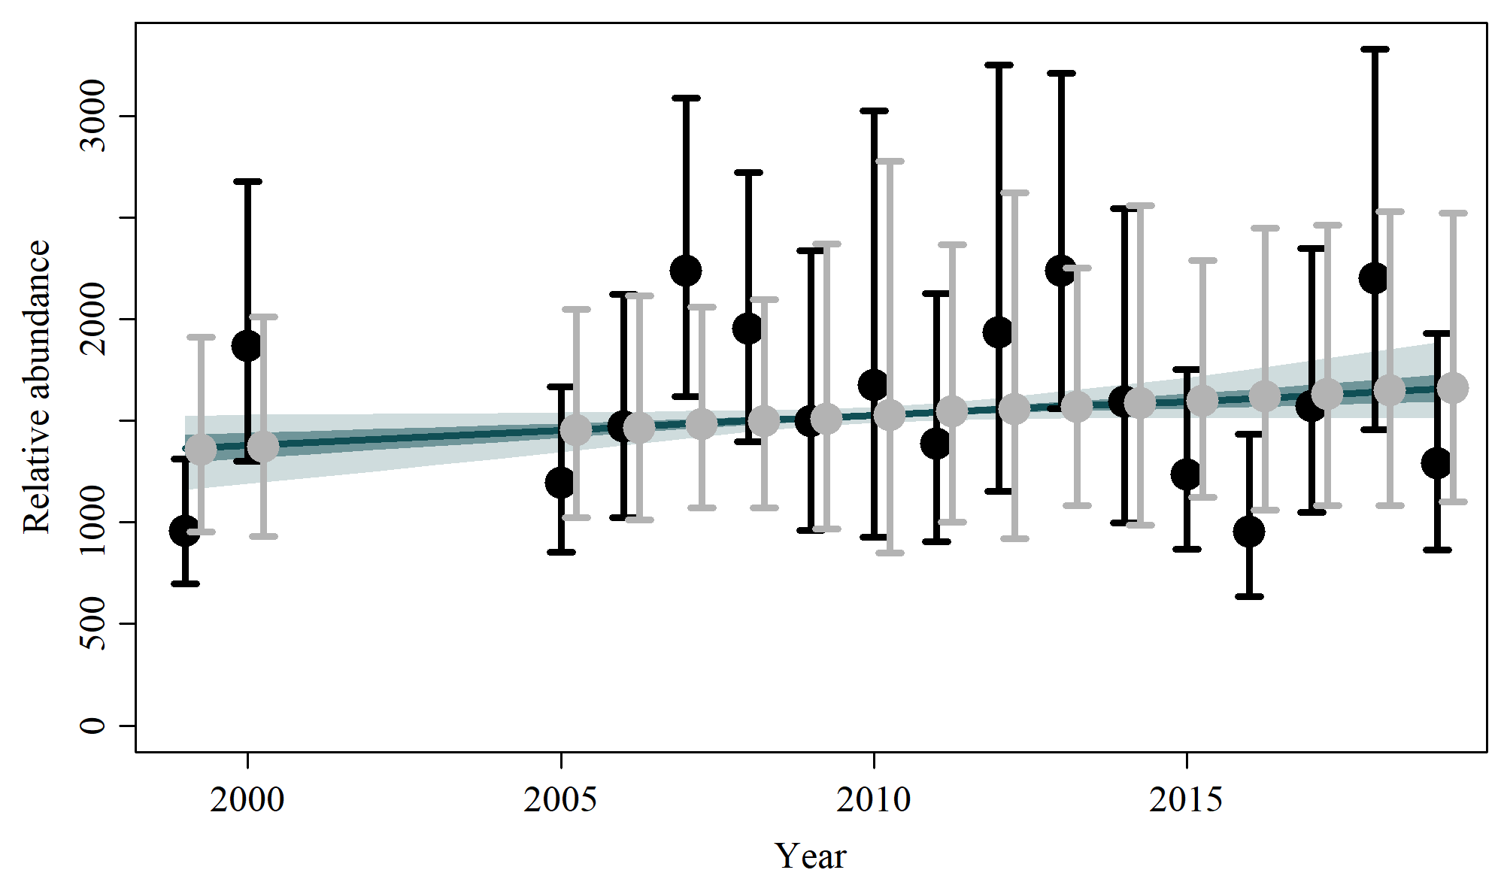

S3.7 Scen 6

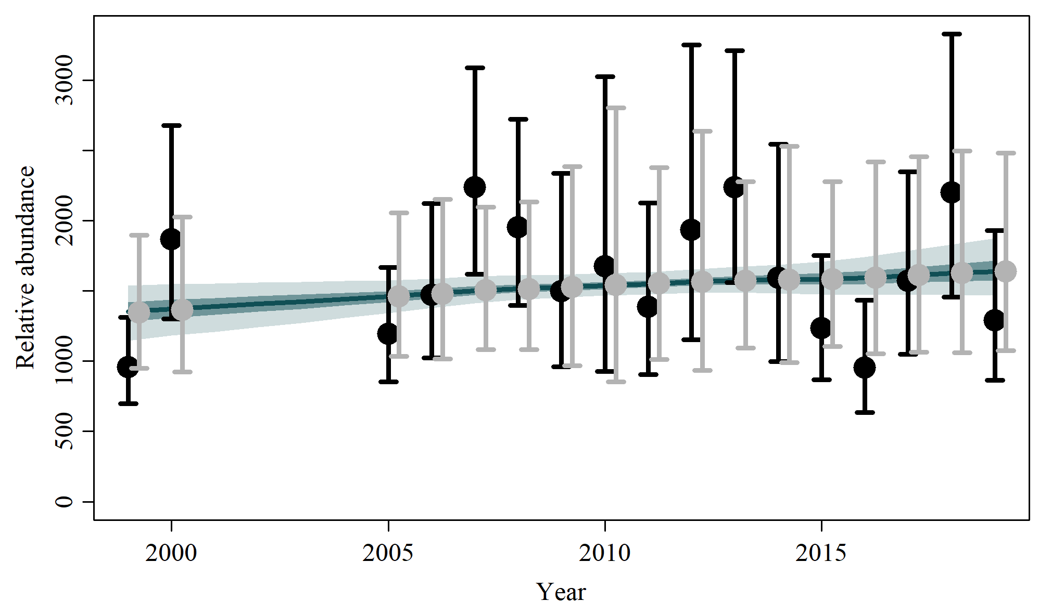

S3.8 Scen 7

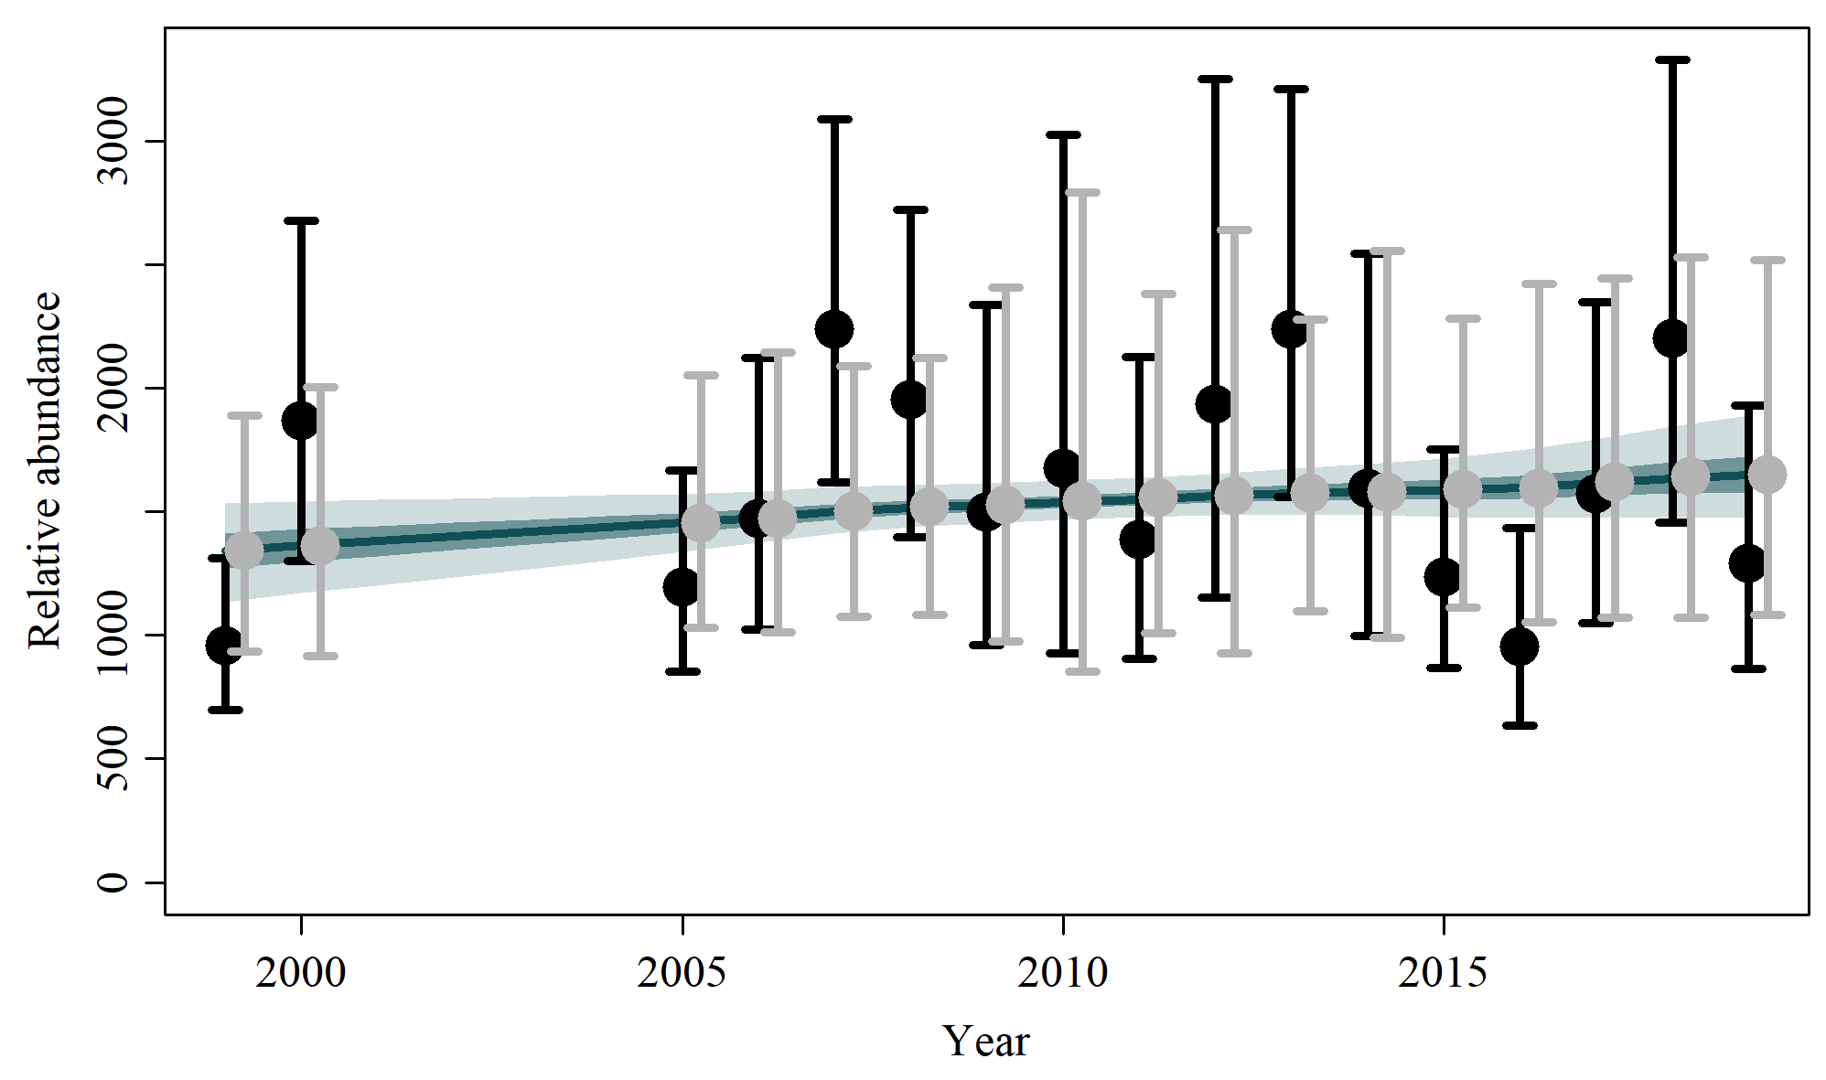

S3.9 Scen 8

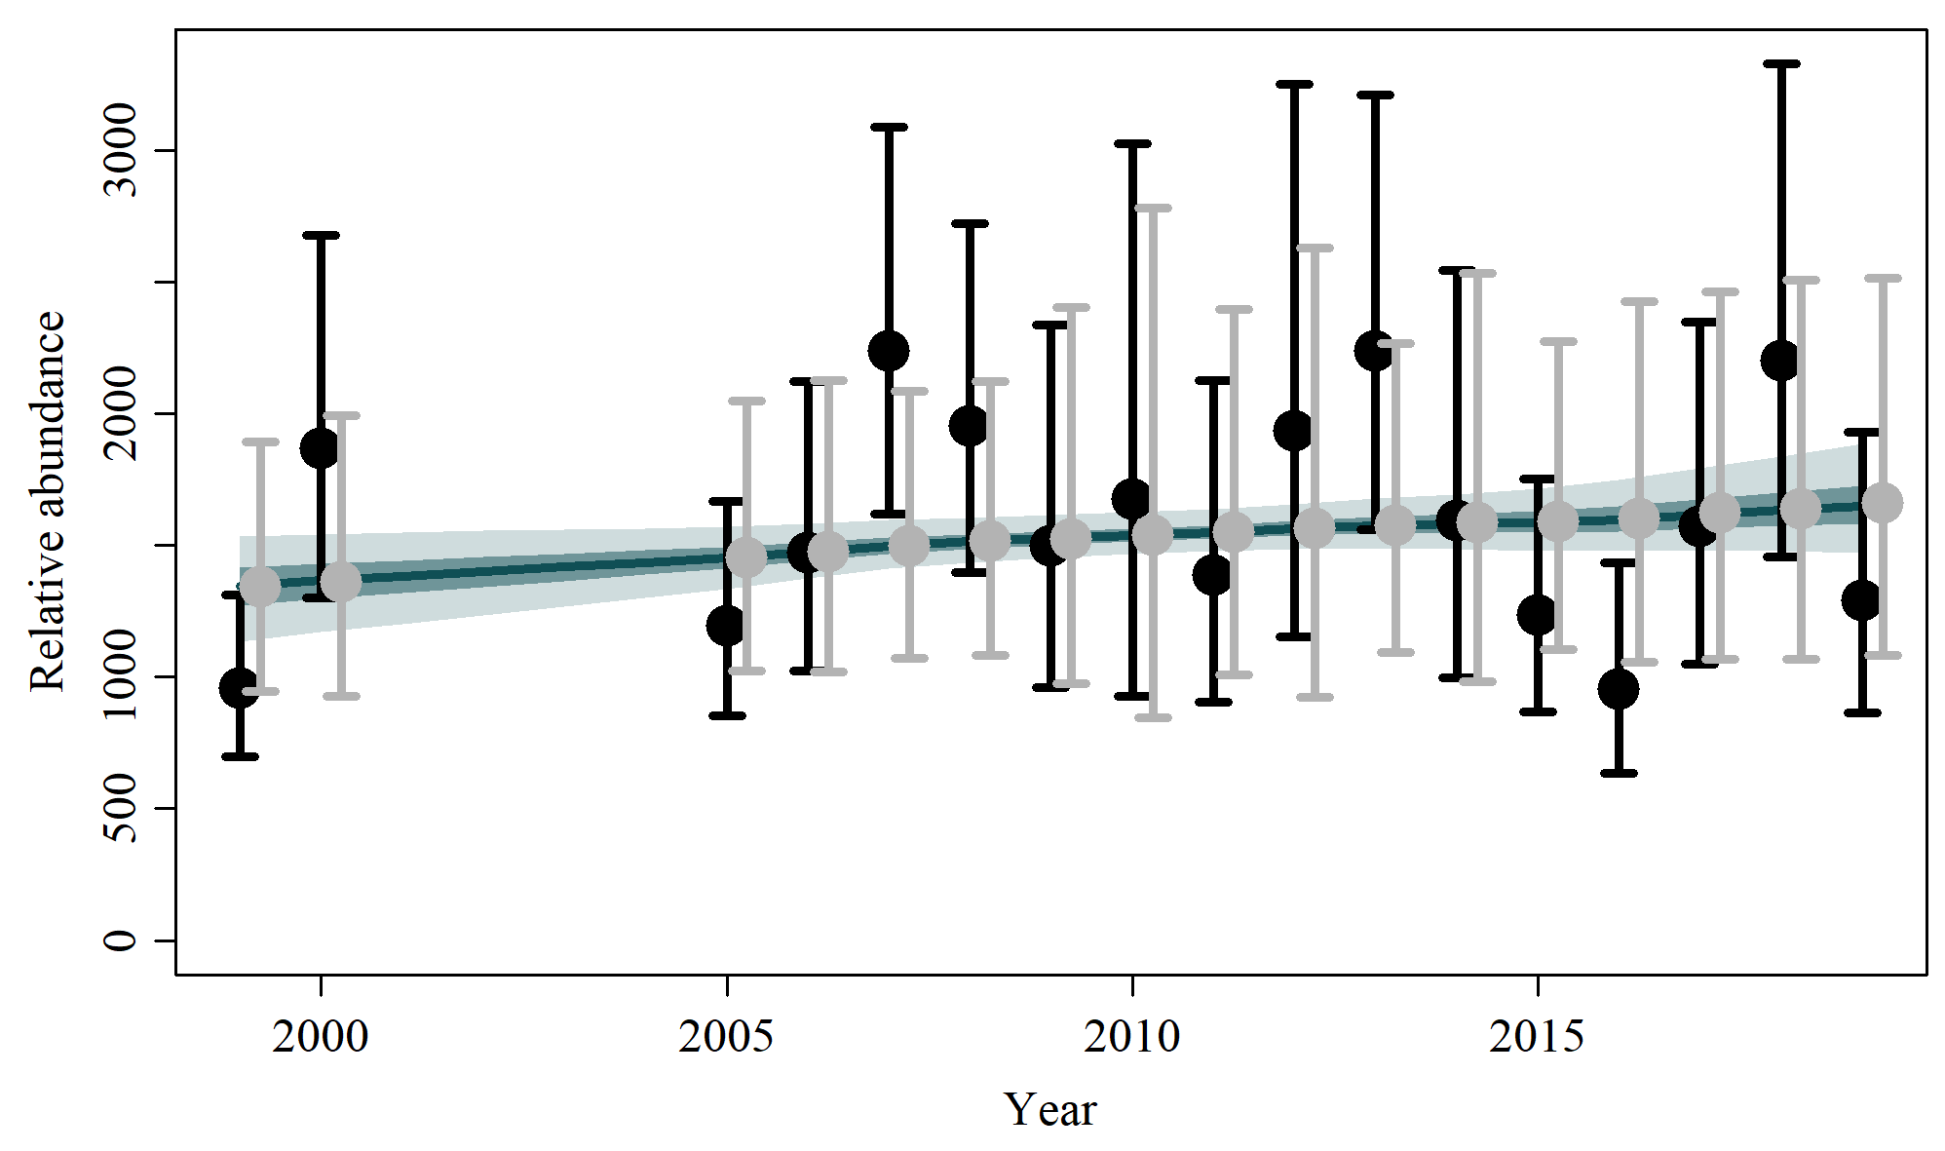

S3.10 Scen 9

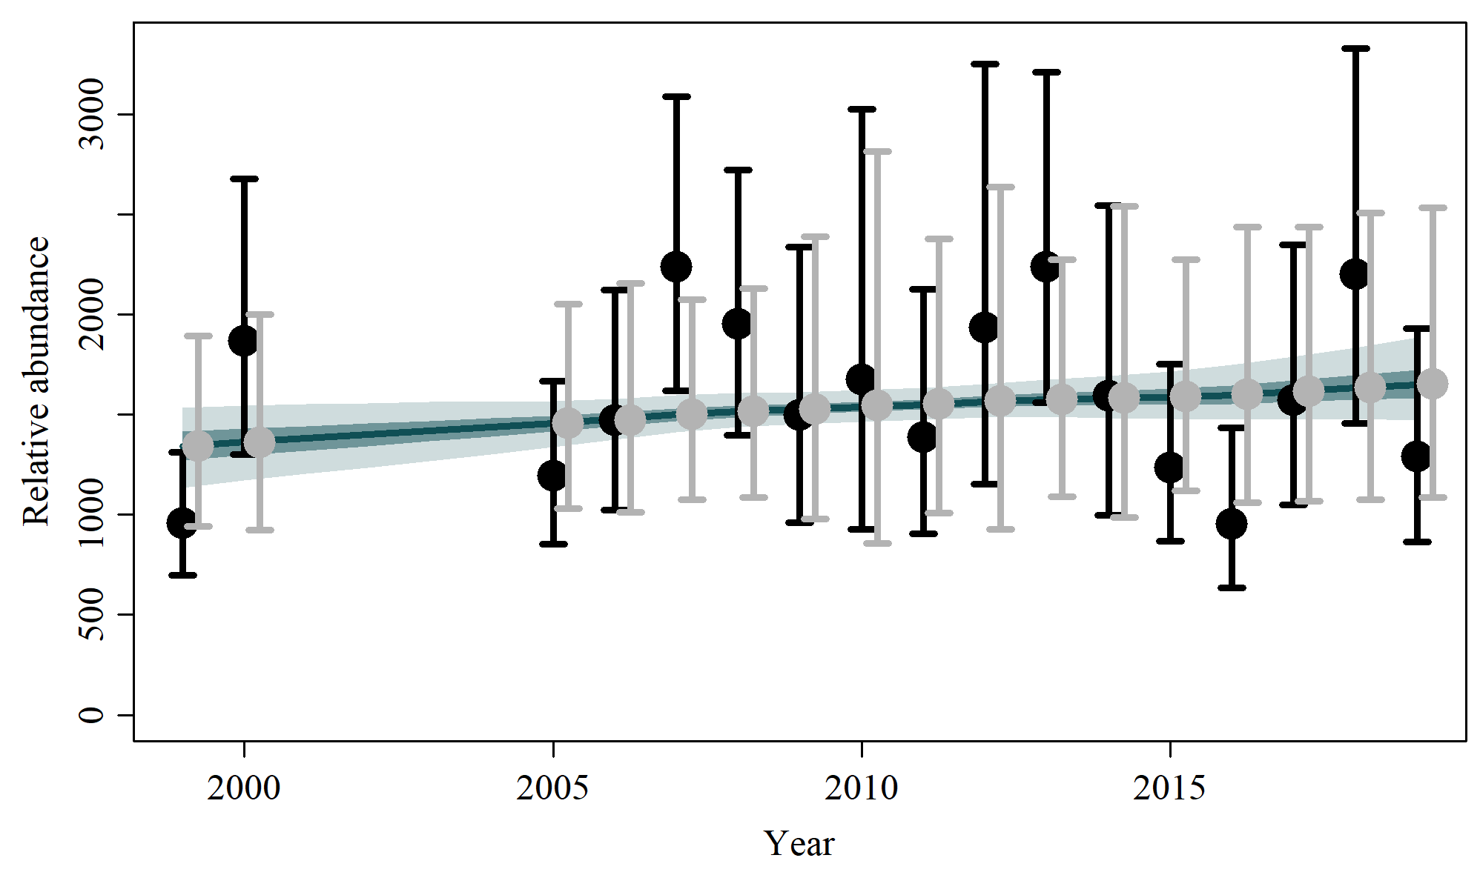

S3.11 Scen 10

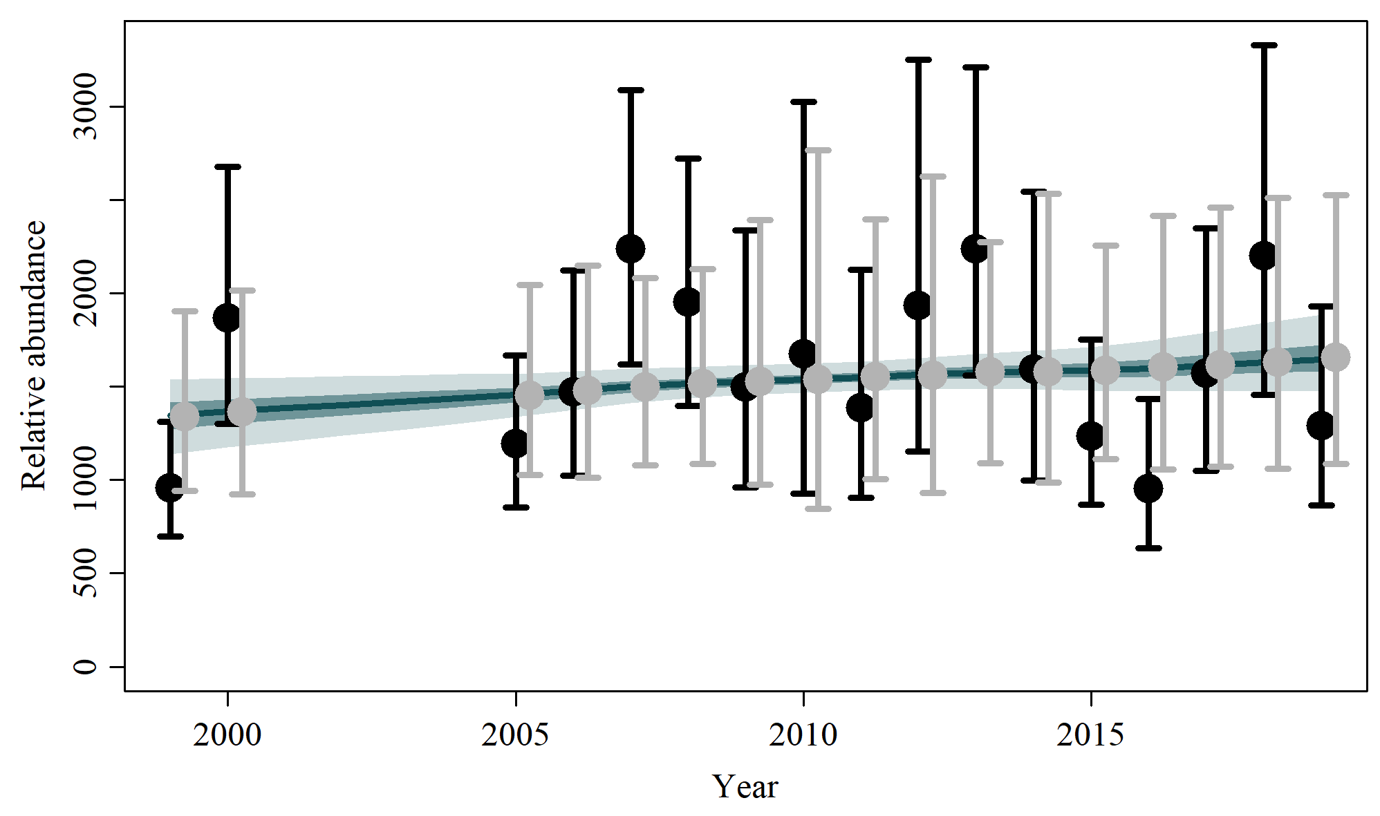

S3.12 Scen 11

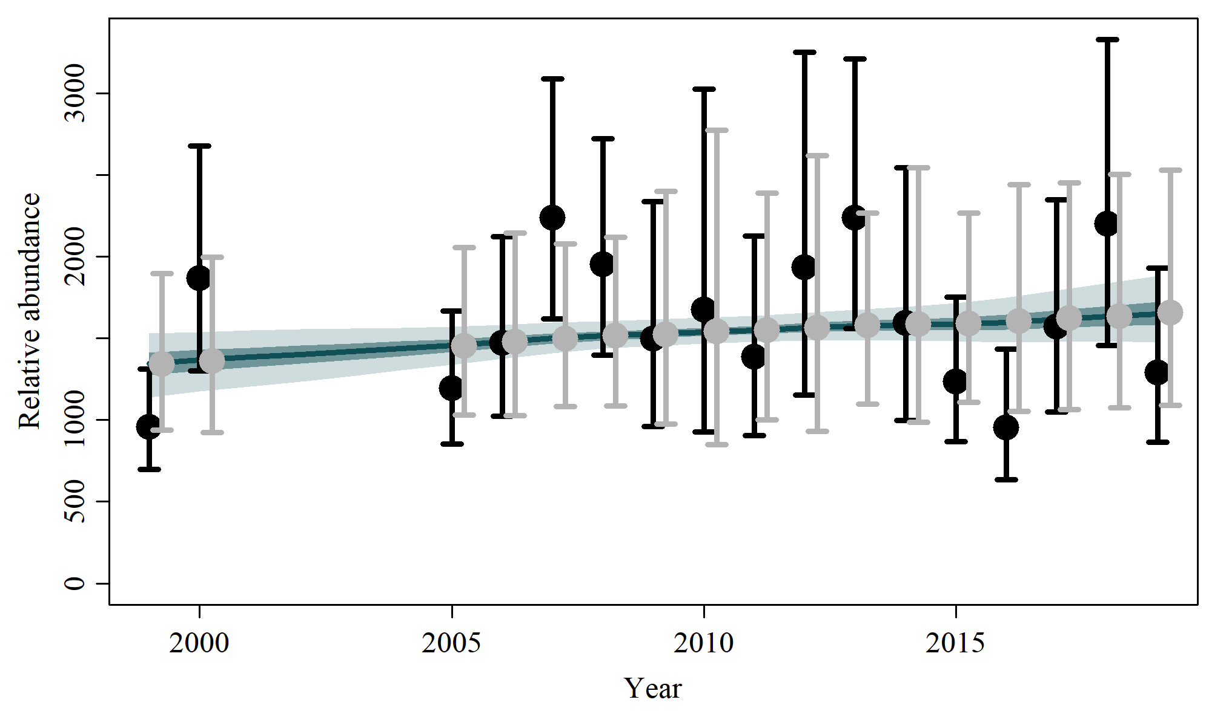

S3.13 Scen 12

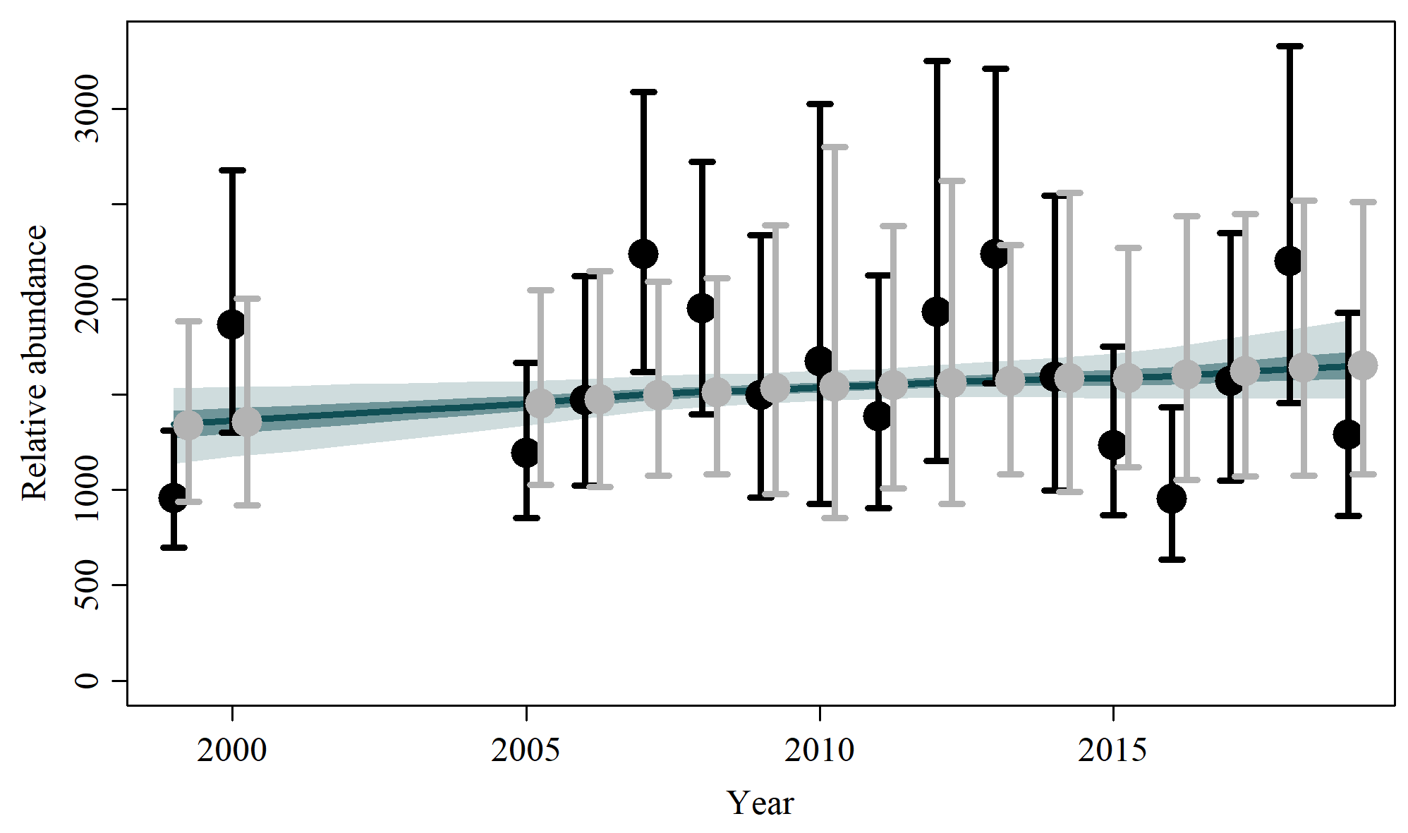

S3.14 Scen 13

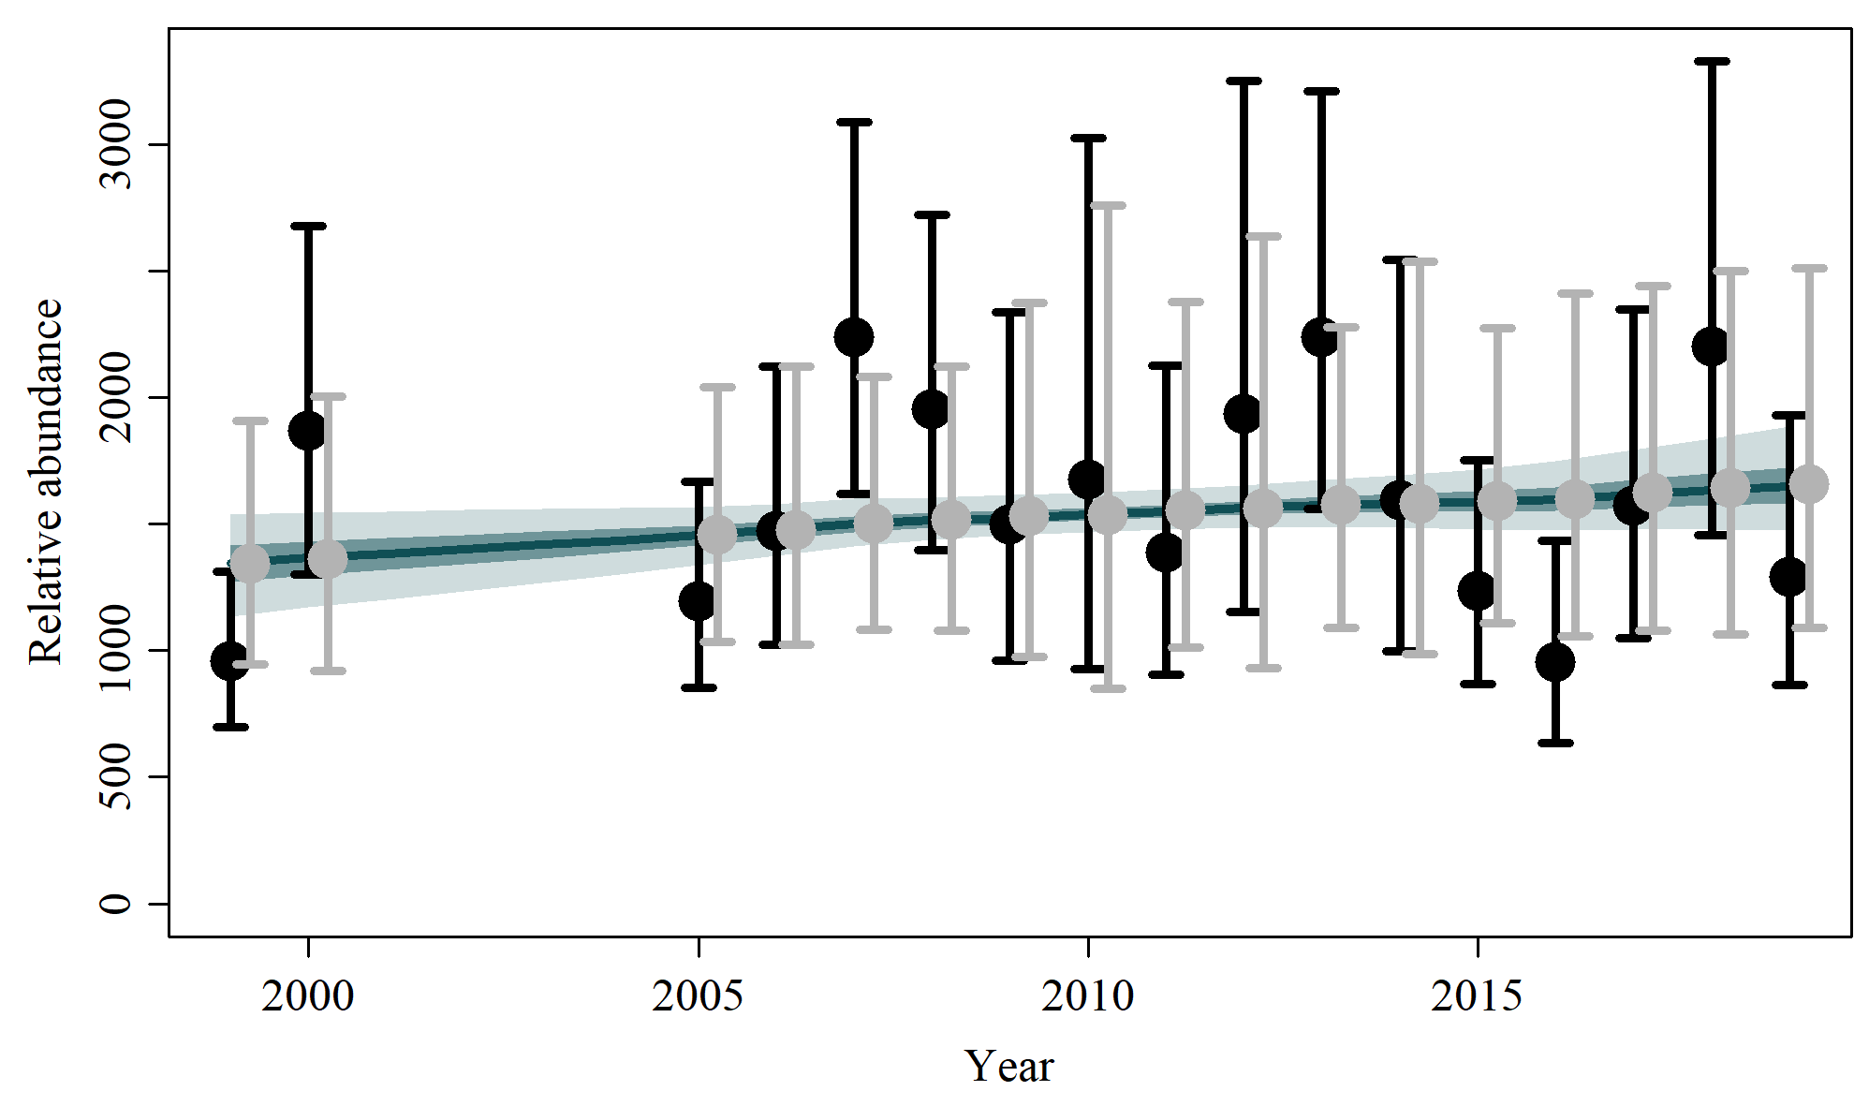

S3.15 Scen 14

